INSTRUCTIONS:

NEW USER REQUEST FORM

The New User Request form is password protected. Please send an email from your CJ or LE agency to TLETS@DPS.Texas.gov if you need the password. Please double-check the information on the form before submitting it. Errors on the form may cause delays, rejection, or a request to be processed with inaccuracies.

Please tag the subject line of the e-mail with [URF] and send the completed User Request Form to TLETS@DPS.Texas.gov Requests are to be submitted as an attached Word document only (.doc or .docx). It is imperative that every attempt be made to use the password protected word documents, this ensures the security of the user’s private information.

If there are any questions, please feel free to contact TCIC Training PRIOR to submitting the request. Call at 512-424-2832 during normal business hours (8a-5p, Monday through Friday), or email: tcic.training@dps.texas.gov

The TCIC User Request Form is designed to tab between columns. Do NOT use the Enter key. Using the Enter key will cause the field you are working on to have format issues. If you hit Enter, just hit the backspace and it should fix the issue.

If you are a Terminal Agency Coordinator (TAC) with OpenFox Configurator access you may disable users and note it in their info tab and do not need to notify TCIC Training or TLETS Operations. If a user is disabled they may appear in your agency roster for some time until the user is moved to another agency.

It is vital the TCIC User Request Form is filled out correctly and completely. Any key information such as PID, SSN, Name, or DOB that is not accurate can potentially cause problems to the User Account. Leaving blank spaces in Required Fields may cause the form to be returned with no action taken.

- List the Page Number (if multiple pages).

- List the Requestors First and Last Name, and Title and TLETS ID.

- Indicate the Agency Name (Do not abbreviate the city or county, but it is OK to abbreviate PD, SO, JP, Pct etc.)

- Indicate the Date of the Request.

- List the Requestors/Terminal Agency Coordinator’s Telephone Number, and E-mail address.

Record the type of request needed (You may need more than one line per user):

- Add - new users to your agency (either brand new or moved from other agency)

- Modify - existing users listed with your Agency

- Disable –If a user is longer with your agency or needs to be disabled due to Internal Affairs investigation. Disable requests require only USER ID, First Name, Last Name, and social security number.

- Profile 1- User’s agency that they are employed with

- Profile 2- User’s terminal access ORI

- If a user had more than 2 profiles, they may have another job at another agency or need access to multiple terminals at like a Communication Center. This requires communication with you and the user to see if they have another job.

- ***** If you do not know what agency your users are under and have access to look into Configurator under a current user you have and copy from theirs. Here is an example:
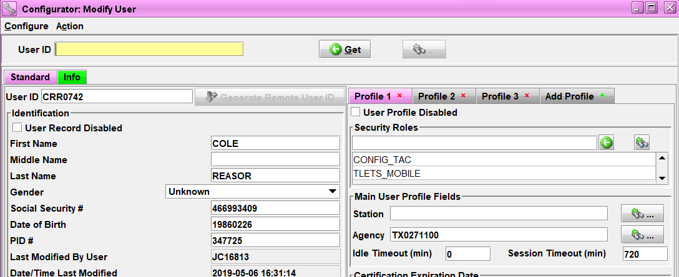
So this user has 3 profiles, meaning the Profile 1 is the agency that he is employed with under Agency ORI TX0271100, but under Profile 2 and 3 will be with a different Agency ORI for terminal access or another job. Please keep in mind NOT ALL agencies will have more than 1 profile.

Users ID: If not known, leave BLANK.

First Name: Self Explanatory (Correction to Configurator if needed) Last Name: Self Explanatory (Correction to Configurator if needed) SSN: Provide full SSN.
DOB: Provide Date of Birth

PID: This is the TCOLE Personal Identification number (if available)

Agency Name: Do not abbreviate the City or County, but it is OK to abbreviate PD, SO, JP, Pct etc.

Desktop Admin: This is to see all the terminals transactions (message log) in the past 14 days, mainly for dispatchers and supervisors (use to be called Shared Inbox)

Main Roles: Review below for guidance:
- TCIC/TLETS Peace Officer: This online course is offered for personnel who receive or contribute to TCIC/NCIC records but do not operate a terminal. Examples would be: sworn peace officers, who do not touch or operate a terminal, federal agents and border patrol agents.
- TCIC/TLETS Criminal Justice Practitioners: This online course is offered for those users who handle, receive or receive benefit from the TCIC/NCIC system but do not operate a terminal. Examples would be: court clerks, jailers, judges, district/county attorneys or adult probation officers.
- TCIC/TLETS Mobile: This course is for operators who perform TCIC/NCIC functions at any level lower than full access. Generally, this pertains to inquiry only, including mobile digital terminal (MDT) or laptop computer operators. It also covers information about driver license and vehicle registration.
- TCIC/TLETS Less Than Full Access: This course is for operators who perform TCIC/NCIC functions at any level lower than full access. Generally, this pertains to inquiry only. It also covers navigation of the databases that are connected to the TLETS system such as administrative messages, driver license, vehicle registration, and instructions regarding proper procedures for broadcasting in the state and nationwide.
- TCIC/TLETS Full Access: This course is for operators who perform all TCIC/NCIC functions, including inquiry, entry, modification, clearing, canceling, and III functions. It also covers navigation of the databases that are connected to the TLETS system such as administrative messages, driver license, vehicle registration, and instructions regarding proper procedures for broadcasting in the state and nationwide.

Add Ons:
CCH – Computerized Criminal History Access
CCQ – (Continuity of Care) – Issued to authorized jail personnel ONLY.

Name changes: A Terminal Agency Coordinator with OpenFox Configurator access may modify the name of a user in their agency (marriage, name change etc.). There is no need to inform TCIC Training. If your agency does not have a TAC with OpenFox Configurator you may submit a user request form to have their name modified.
Desktop Admin: This is to see all the terminals transactions (message log) in the past 14 days, mainly for dispatchers and supervisors (use to be called Shared Inbox)

File name: Name the user request form in the “DATE OF REQUEST AGENCY NAME” format. For example, a user request submitted from River City Police Department on November 1st, 2022 would be “11012022 RIVER CITY PD”.

Additional notes should be documented in the comment box on the user request form itself, or in the e-mail request if unable to use comment box.

