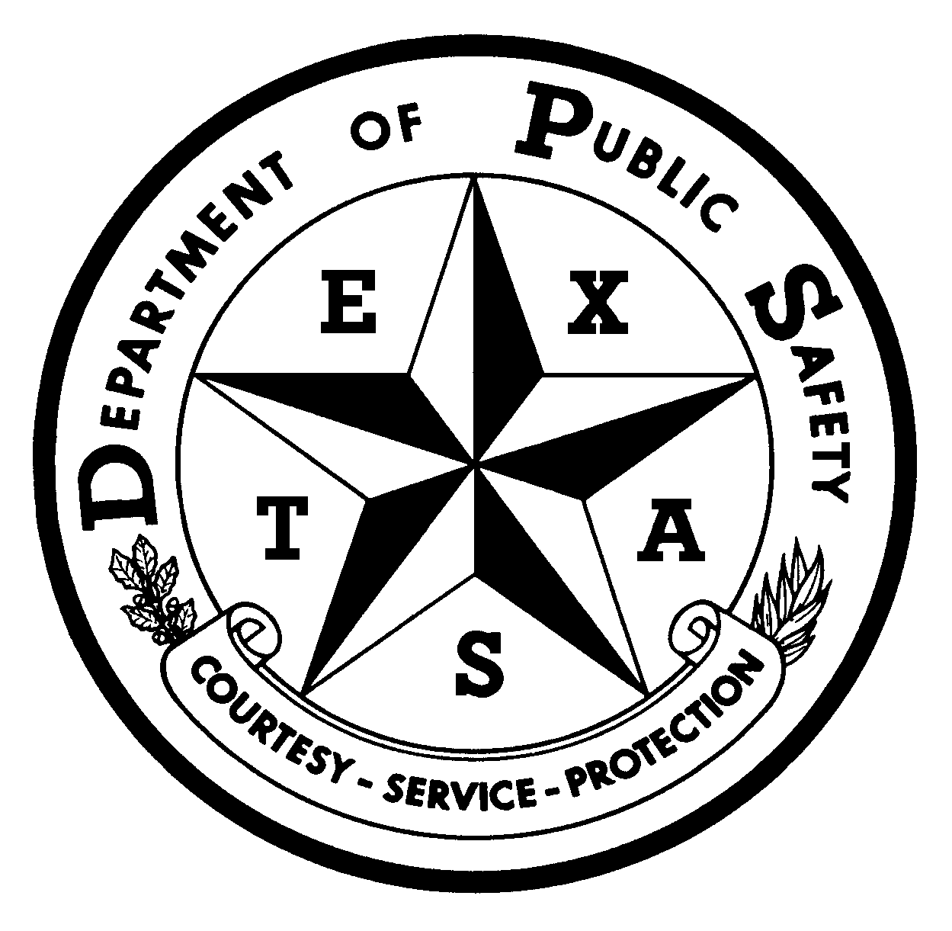 |  | REPORT OF VALID POSITIVE RESULT ON  ALCOHOL TEST UNDER TRC 644.252 |  |  |  |  |  |  |  |  |  | 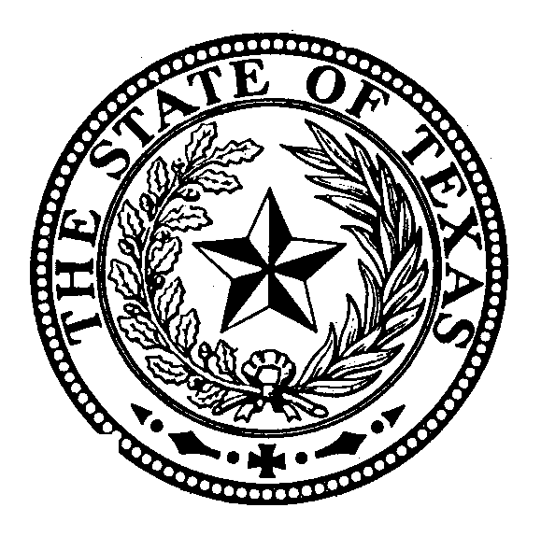
A. ID | Name of Motor Carrier |  |  |  |  |  |  | Date of Alcohol Test
A. ID | Name of Individual Tested |  |  | Social Security Number |  | CDL Number & State |  |  |  |  | Birthdate
B. Instructions | INSTRUCTIONS FOR THE COMPLETION OF THE  REPORT OF POSITIVE ALCOHOL TEST UNDER TRC 644.252:  TO THE MOTOR CARRIER  - You must complete and sign the “Certificate of Motor Carrier” section.  - You must attach a legible copy of the completed federal Alcohol Testing Form with the screening and confirmation test results included or affixed. If the donor refused to provide a specimen, you do not need documentation from the Breath Alcohol Technician (BAT).  - Deliver or mail this form and the supporting documentation to: MCS Section Supervisor, Motor Carrier Bureau, Texas Department of Public Safety, 6200 Guadalupe, MSC# 0521, Austin, Texas 78752-4019.  Legible copies may be sent by facsimile /email to 512-424-5310 or MCB.VPR@dps.texas.gov  - Retain a copy of this form and the completed Alcohol Testing Form in the Motor Carrier records as required by 49 CFR Parts 40 and 382 (or other parts applicable to CDL holders).  - You must forward this report to the department within ten days of receiving the completed test results.
C. Certificate of Motor Carrier | By signing below, I the authorized representative of the Motor Carrier listed above, certify the following:  - The Motor Carrier listed above: Has an in-house drug and alcohol testing program that meets the federal requirements of 49 CFR Parts 40 and 382 (or other parts applicable to CDL holders); OR  Is a member of a consortium, as defined in 49 CFR 382.107, that provides drug and alcohol testing that meets the federal requirements of 49 CFR Parts 40 and 382 (or other parts applicable to CDL holders).
C. Certificate of Motor Carrier | Name of Consortium:
C. Certificate of Motor Carrier | - The individual tested is subject to alcohol testing by the Motor Carrier, and was tested for the following reason:  Random Reasonable Suspicion Post-Accident Return to Duty Follow-up Pre-employment  Other: ; AND
C. Certificate of Motor Carrier | Had a 0.04 or more breath alcohol level under 49 CFR Parts 40 and 382 (or other parts applicable to CDL holders) (NOTE: a copy of the federal Alcohol Testing Form must be provided, with the screening and confirmation test results included or affixed to the federal Alcohol Testing Form); OR  Refused to submit to an alcohol test (NOTE: Supporting documents not required)  I further certify that I have reviewed the motor carrier’s records and that the information contained in this certificate is true and correct to the best of my knowledge.
C. Certificate of Motor Carrier | Printed Name of Designated Motor Carrier Representative Telephone Number
C. Certificate of Motor Carrier | Address
C. Certificate of Motor Carrier | Signature of Designated Motor Carrier Representative  X |  |  |  | City |  | State |  |  | Zip Code
Mail form/attachments to the MCS Supervisor, Motor Carrier Bureau, Texas Department of Public Safety, 6200 Guadalupe, MSC# 0521, Austin, Texas 78752-4019, FAX LEGIBLE copy to 512-424-5310 or email to MCB.VPR@dps.texas.gov .

