Identix, Inc.
510 N. Pastoria Avenue
Sunnyvale, CA 94086
(408) 739-2000
(408) 739-3308 (FAX)

Texas Demographic Data Gateway

Installation and User Guide

Version:
V3.20 June 15, 1999

1 Overview 6
2 Installation 7
2.1 System Requirements 7
2.1.1 Hardware 7
2.1.2 Software 7
2.2 Installation Procedure 7
2.2.1 Windows NT Workstation 4.0 Operating System 7
2.2.2 Remote Services Management (RSM) 8
2.2.3 DDG Server Software 8
2.2.4 OS/2 Warp FTP Server 9
2.2.5 Windows NT 4.0 FTP Server 9
2.2.6 IBM AS/400 FTP Server 10
3 Configuration Scenarios 12
3.1 Single LS21 LiveScan in Push Down Mode 12
3.2 Multiple LS21 LiveScans in Pull Down Mode 14
3.3 Multiple LS21 LiveScans with AWS in Pull Down Mode 16
4 Operation 19
4.1 Creating a New Configuration Database 20
4.2 Configuring the DDG Node 23
4.2.1 DDG Node - Parameters Tab 23
4.2.2 DDG Node - Timeouts Tab 25
4.2.3 DDG Node - FTP Tab 27
4.3 Configuring the Local RMS Host Node 29
4.3.1 Local RMS Host - Parameters Tab 29
4.3.2 Local RMS Host - Timeouts Tab 31
4.3.3 Local RMS Host - FTP Tab 33
4.4 Configuring the LS21 / AWS Node 35
4.4.1 LS21 / AWS - Parameters Tab 35
4.4.2 LS21 / AWS - Timeouts Tab 37
4.4.3 LS21 / AWS - FTP Tab 39
4.4.4 LS21 / AWS - NATMS Tab 41
4.5 Data Grid Display 43
4.6 Starting and Stopping the Gateway 45

5 Gateway Data Processing 46
5.1 System Workflow 46
5.2 Data and Process Relationships 48
5.3 Local RMS Host Communication Interface 50
5.4 LiveScan Connection Architecture 51
5.5 File Transfer Interface – Local RMS Host with DDG 51
5.5.1 EAR File 51
5.5.2 READY File 52
5.5.3 EARACK File 52
5.5.4 NATMS Message Files 53
6 Maintenance and Troubleshooting 55
6.1 Automatic Gateway Startup With Backup 55
6.2 Manual Backup Operations 55
6.2.1 Baseline Configuration Backup 55
6.2.2 Compacting the Configuration Database. 56
6.2.3 Manually Pruning the Message Log 57
6.3 Error Reporting - Routine and Catastrophic 57
Appendix A - Message Log Records 58
Appendix B – FTP Configuration 61
B.1 Windows NT 4.0 FTP Server 61
B.2 OS/2 Warp FTP Server 61
B.3 IBM RS/6000 Unix FTP Server 61
B.4 IBM AS/400 FTP Server 62
B.5 Other FTP Server Types 62
Appendix C: EARACK Messages 64
Appendix D: EAR File Layout 66
D.1 IDENTIFICATION SECTION (EH) 66
D.2 IDENTIFICATION SUPPLEMENTAL SEGMENT (EHN) 68
D.3 ARREST SEGMENT (ER2) 70
Appendix E: NEC AFIS Response Message Formats 72
E.1 Return Message Formats 72
E.1.1 HEADER FORMAT (First four lines of each message) 73
E.1.2 ADMINISTRATIVE MESSAGE FORMAT 73
E.1.3 ACKNOWLEDGMENT MESSAGE FORMAT 73
E.1.4 REJECT MESSAGE FORMAT 73
E.1.5 IDENTIFICATION RESPONSE FORMAT 74
E.1.6 NON-CRITICAL ERROR RETURN (corrected at DPS - Austin) 75
E.1.7 FBI IDENTIFICATION RESPONSE FORMAT 76
E.1.8 Flow Control Message Formats 76
E.2 Message Code Tables 77
E.2.1 ADMINISTRATIVE RESPONSE CODE – TABLE 11.1 77
E.2.2 ACCEPT RESPONSE CODE - TABLE 11.2 77
E.2.3 REJECT RESPONSE CODE - TABLE 11.3 77
E.3 MESSAGE EXAMPLES 78
E.3.1 Administrative Messages 78
E.3.2 Acknowledgement Messages 78
E.3.3 Reject Messages 79
E.3.4 Identification Response Messages 80
E.3.5 Non-critical Error Messages 82

Table of Figures
Figure 1 – Single LS21 LiveScan in Push Down Mode 12
Figure 2 – MULTIPLE LS21 LiveScans in PuLL Down Mode 14
Figure 3 – MULTIPLE LS21 LiveScans WITH AWS in PuLL Down Mode 16
Figure 4 – DDG User Interface at Startup, with Configuration Menu Selections Visible 19
Figure 5 – DDG User Interface after Using “New” Menu Item to Create New Configuration Database 21
Figure 6 – DDG User Interface after SELECTING DDG Node 23
Figure 7 – DDG User Interface after Selecting the Timeouts Tab for A DDG Node 25
Figure 8 – DDG User Interface after Selecting the FTP Tab for a DDG Node 27
Figure 9 – DDG User Interface after SELECTING Local RMS Host 29
Figure 10 – DDG User Interface after Selecting the Timeouts Tab for A Local RMS Host 31
Figure 11 – DDG User Interface after Selecting the FTP Tab for a Local RMS Host 33
Figure 12 – DDG User Interface after SELECTING LS21 / AWS 35
Figure 13 – DDG User Interface after Selecting the Timeouts Tab for A LS21 / AWS 37
Figure 14 – DDG User Interface after Selecting the FTP Tab for a LS21 / AWS 39
Figure 15 – DDG User Interface after Selecting the NATMS Tab for a LS21 / AWS 41
Figure 16 – DATA GRID DISPLAY 43
Figure 17 – DDG Gateway Control Panel 45
Figure 18 – System Process Flow for Baseline DDG Implementation 47
Figure 19 – PROcess and data organization 49

Overview

The Texas Demographic Data Gateway (DDG) server program provides a means to interface LS21 LiveScan units or AWS workstations with proprietary third party Record Management Systems (RMS) host applications. The DDG provides the facilities to access arrest booking demographic data in the proprietary RMS application environment and to make this data available to either a single or multiple LS21 LiveScan units or AWS workstations. The demographic record interface to the LS21/AWS stations is via ASCII file interchange using the FCS protocol. This approach eliminates retyping any demographic data that may be accessed from the proprietary host computer.

While the major function of the DDG is to move the demographic data from the local RMS host to the LS21/AWS units, the DDG also optionally provides the facility to move NATMS return reports from LS21/AWS units back to the local RMS host. Additionally, the DDG can be configured to do SID updates and print requests on the originating LS21 or AWS.

A detailed description of DDG data processing functions and local RMS host interface requirements is contained later in this document.

In addition, refer to the document Texas DPS Computerized Criminal History (CCH) Data Dictionary (October 6, 1998) for information regarding the demographic data elements transmitted to the DDG from the local RMS host.

A description of the interface between the LS21/AWS and the NEC NATMS is available in the document Live Scan to NEC NATMS Interface Specification – Texas Special (Revision 3.2T - February 3, 1999).

The FCS requester protocol for record push down mode, record update, and record print is described in the Identix document TP-600 Basic File Communications Protocol – Service Requester – Document #100-067.

The FCS provider protocol for record pull down mode is described in the Identix document TP-600 File Communications – Retrieval Subset – Document #100-078

The LS21 / AWS configuration is described in the Identix document TouchPrint-600 Configuration Variables – Document #100-075

Installation

System Requirements

Hardware

Minimum requirements: Intel Pentium class 100Mhz CPU, 32 Megabytes of DRAM, 1.0 Gigabyte Hard Drive, LAN adapter supporting TCP/IP protocol, 800 x 600 video display (256 colors), mouse.

Software

Minimum requirements: Microsoft Windows NT 4.0 Workstation, Windows NT Service Pack 4, and Internet Explorer 4.01. Identix supplied Texas DDG server software.

Installation Procedure

Windows NT Workstation 4.0 Operating System

Install the Windows NT Workstation 4.0 operating system from CD-ROM per the instructions as supplied by Microsoft. You will need to configure one or more network adapters with the TCP/IP protocol.

The DDG requires the disk partition to be formatted using the NTFS file system. The NTFS option can be selected during installation of Windows NT if you will be using or creating a new partition. If Windows NT has already been installed in a FAT partition, then you will need to use the following command line to convert the partition to NTFS:

CONVERT C: /FS:NTFS

Since this is the partition containing the operating system, the actual conversion will be deferred to the next reboot. A successful conversion requires some free space in the partition. The conversion operation will not be started if sufficient free space is not available

Installation of NT 4.0 Service Pack 4 is mandatory! This service pack provides many error corrections including adjustments for the Y2K problem. Internet Explorer 4.01 is necessary because it provides many components for a wide variety of operating system functions, not just web browsing facilities. Note that if Remote Services Management (RSM) is already installed, then you must install a patch file before installing Service Pack 4. See Section 2.2.2 below for a discussion on RSM related patches.

NT 4.0 Service Pack 5, which includes previous service packs, has recently become available. Neither the DDG nor Remote Services Management (RSM) has been tested with Service Pack 5.

Remote Services Management (RSM)

The Remote Services Management (RSM) program allows remote control of a mix of Windows NT and OS/2 Warp machines. Windows NT Service Pack 4 is incompatible with certain versions of RSM, and after installation of Service Pack 4, a “blue screen” crash will occur after reboot.

If certain versions of RSM are installed on the DDG, then an upgrade procedure must be done before installing Service Pack 4. For RSM versions 42A1 and 42A2, install the files contained in the “Ginag42a.zip” patch file into the “C:\Winnt\System32” directory. For RSM version 41Bx, install the files contained in the “Ginag41b.zip” patch file. For RSM version 41Ax, install the files contained in the “Ginag41a.zip” patch file. The patch files are available in the \RSM directory on the DDG CD-R disk.

If you have already installed NT Service Pack 4, and want to add RSM, then:

1. Determine what version of RSM you are going to install, so that you know which patch files to install.

2. Install RSM. At the end of the RSM install, when it asks you if you wish to reboot to complete the install process, answer "NO". Exit the RSM install process without reboot.

3. Copy the patch files as described below.

4. Reboot NT to complete the RSM install process.

RSM versions after 42A2 may already incorporate the patch. It is unknown if there are any additional conflicts between RSM and Windows NT Service Pack 5.

Sales and support for RSM are available from:

Peregrine Systems Inc.
12670 High Bluff Drive
San Diego, CA 92130
(619) 481-5000
(800) 960-9998 (support center)
http://www.peregrine.com

DDG Server Software

The entire DDG server program, along with supporting data files and system .dll and .ocx files, is contained on a CD-R ROM. Place this CD-R in the CD drive, then run the “Setup.exe” file located in the root directory of the CD-R. The installation process will proceed as directed by the installation program. A reboot of the system may be required, as prompted by the installation program.

The installation program will copy a variety of system .dll and .ocx files to the “Winnt/System32” directory. It will by default build a new directory “TDG” in the “Program Files” folder and this name and location can be changed by the operator during the installation process. A new “Texas DDG” item will be created in the Windows NT “Start” menu, to allow the DDG program to be started.

Configuration of the DDG server program is discussed below in the operation section.

OS/2 Warp FTP Server

Two data access mechanisms are available for FCS operations from the DDG to the LS21 or AWS computers. The default mechanism is FTP client. Also available is shared file systems using various transports, such as FTP server, NFS, NetWare, NetBios, etc. For FTP client access from the DDG, the OS/2 FTP Server must be configured properly to allow access to the FCS file system directory.

Open the OS/2 TCP/IP folder and then click the TCP Configuration Notebook icon. Use the AutoStart notebook tab to select the "inetd super server", "enable others to access your files by using FTP". Use the Services tab to define a TRUSER as "Identix", then edit it for a password "Identix" and set the read and write directory access fields to "C:\IDXRCV". Match the user ID and passwords on the DDG configuration screen. You need user ID's and passwords as some of the FTP commands may be disallowed by some FTP servers when in anonymous login mode.

Windows NT 4.0 FTP Server

Normally the DDG accesses the local RMS host and the LS21 / AWS units using FTP client at the DDG. Alternate communication using shared file systems or FTP server at the DDG are possible. The following is the general process to install FTP server in the DDG if it is desired to have the local RMS host use FTP client to access the DDG FTP server.

1. The FTP Server is installed as part of the NT 4.0 Option Pack. This CD-ROM is included in the same jewel case with the NT 4.0 Service Pack 4 CD-ROM. The Option Pack contains many options which should NOT be installed on the DDG, so use the custom installation selection.

2. When you start the Option Pack Install after inserting the CD, a message box pops up once or twice indicating that Option Pack has not been tested with Service Pack 4. This message can be dismissed, and you will reinstall Service Pack 4 after installing the option Pack.

3. Select the "Custom" installation option, which allows you to select what will be installed.

4. Select the components needed. Full checkmarks on "Microsoft Management Console", "NT Option Pack Common Files". "Personal Web Server" (will end up as gray background checkmark). Turning off the other selections will raise warning messages, ignore the warnings. Select Personal Web Server, then click the "Show Subcomponents..." button. This will pop up another selection menu. Select "File Transfer Protocol (FTP) Server" and "Internet Service Manager". Uncheck any of the other selections. When you exit the popup, the check mark on "Personal Web Server" will have a gray background, indicating that only part of that selection (FTP Server) will be installed.

5. Click the "Next" button to move to the directory selection screen. The default selections are fine, should be "C:\Inetpub\ftproot" for the FTP server. Click the "Finish" button to install the FTP Server and supporting components.

6. The directory "C:\Inetpub\ftproot" is the root point for FTP access. Create a directory "lsdata" at this point for storage of EAR, READY, EARACK and NATMS files. The local RMS host will use its FTP client to access this directory. The DDG will be configured to use the "lsdata" directory as the mount point for RMS data.

7. Set up a user account such as "Identix" with the password "Identix" with the Start|Programs|Administrative_Tools|User_Manager menu selection. This will be the account used for FTP logins.

8. "Windows NT 4.0 Option Pack" is new folder that has been added to the Start Menu|Programs selection. From this folder choose "Microsoft Personal Web Server" and "Internet Service Manager". This brings up the Microsoft Management Console, a program that allows configuration and operation of various components such as a web server, transaction server, and FTP server. Only the FTP server has actually been installed. Under "Console Root", select "Internet Information Server", <machine name>, "Default FTP Site". Left click the "Default FTP Site" icon and choose "Properties". This will bring up the "Default FTP Site Properties" notebook screen where the FTP Server can be configured.

9. On the "Security Accounts" tab, uncheck the "Allow Anonymous Connections" box. A security warning message about passwords will appear and can be ignored. The choices with FTP are to allow anonymous access (anyone) or using passwords that could be compromised by someone using a packet sniffer on the network. This is a risk you should discuss with your client.

10. On the "Home Directory" tab, the Local Path box should contain "C:\Inetpub\ftproot". Check the box "Write" to allow writing to the "lsdata" directory which you previously added to "C:\Inetpub\ftproot".

- Configure the DDG to mount the "lsdata" directory in the Local RMS Host configuration box, with the "Use Shared File System" box checked.

IBM AS/400 FTP Server

The information on how to set up FTP server on an IBM AS/400 using OS/400 R3V7 is in Chapter 10 of the manual: OS/400 TCP/IP Configuration and Reference V3. This manual is available online at: http://publib.boulder.ibm.com/pubs/html/as400/online/v3r7eng.htm

After bringing up this web page, use the search feature to find "configuration and reference". This will bring up one manual title. Click that title, which will bring up the table of contents. Scroll down to Chapter 10 for the information on how to set up the FTP server on the version of OS/400 for the IBM AS/400.

IBM has extensive AS/400 documentation available online at http://publib.boulder.ibm.com/pubs/html/as400/online/homeeng1.htm and an AS/400 specific search engine is located at http://www.search400.com/

Configuration Scenarios

The DDG is highly configurable to meet varying installation needs. Some sample configurations are presented below. Other configuration variations are possible.

Single LS21 LiveScan in Push Down Mode

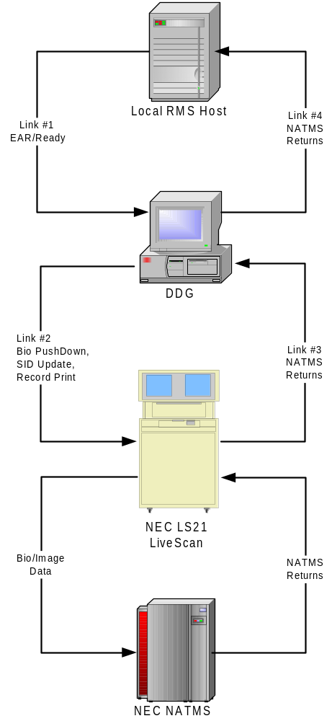

Figure 1 – Single LS21 LiveScan in Push Down Mode

The single LS21 in Push Down mode is one of the simplest configurations. As shown in Figure 1, there are two data flows. The forward path is biographical (or demographic) data flowing from the local RMS host to the DDG. The DDG pushes that data down to the LS21. Finally, the LS21 pushes the biographical data along with the acquired fingerprint images to the NATMS. The reverse path is reports or returns from the NATMS, to the LS21. The DDG can optionally be configured to move the NATMS returns from the LS21 back to the local RMS host.
Those communication links that are configured on the DDG are as follows:
Link #1 – EAR/Ready. This communication link moves the READY.xxx and EAR.xxx files from the local RMS host to the DDG. It also moves EARACK.xxx files from the DDG back to the local RMS host. This link is configured in the local RMS host configuration notebook (Section 4.2 below).
Link #2 – Bio Push Down, SID Update, Record Print. This communication link allows FCS requests to flow from the DDG to the LS21. It provides record creation on the LS21 via FCS requester. If the reverse channel has been configured for SID Updates and/or Record Print functions, then this link is used transmit the appropriate FCS requests from the DDG to the LS21. This link is configured in the LiveScan / AWS configuration notebook (Section 4.3 below).
Link #3 – NATMS Returns. This optional communication link allows the DDG to read the NATMS return messages from the LS21 or AWS message log. This link is configured in the LiveScan / AWS configuration notebook (Section 4.3 below). This link only exists if NATMS returns have been enabled in the LiveScan / AWS configuration notebook.
Link #4 – NATMS Returns. This optional communication link moves the NATMS return messages from the DDT to the local RMS host. This link is configured in the local RMS host configuration notebook (Section 4.2 below). This link only exists if NATMS returns have been enabled in the LiveScan / AWS configuration notebook.
The links that move the Bio/Image Data from the LS21 to the NATMS, and NATMS returns from the NATMS to the LS21, are configured in the LS21.

Multiple LS21 LiveScans in Pull Down Mode

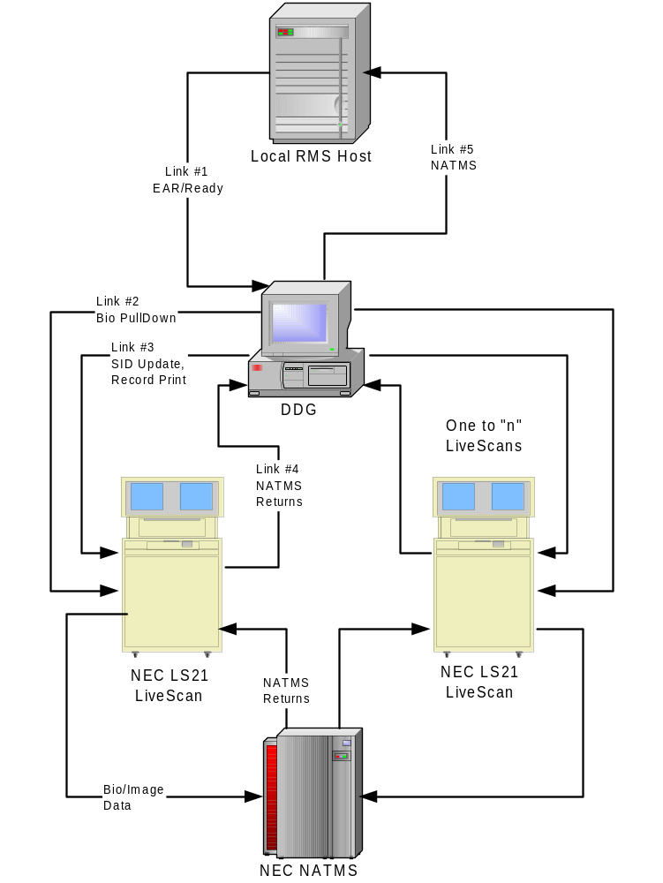

Figure 2 – MULTIPLE LS21 LiveScans in PuLL Down Mode

If multiple LS21 units are required, then the biographical data is held in the DDG until an LS21 operator makes a request. This is termed “pull down” mode and is implemented via the CJIS query capability of the LS21.
As shown in Figure 2, an additional communication link is added to support pull down of biographical data. Also shown is a second LS21. Up to ten LS21 units may be configured. The actual upper limit of LS21 units that can be supported by a single DDG is a function of the DDG memory capacity, CPU speed, and allowable response time to data requests.
There are two data flows. The forward path is biographical (or demographic) data flowing from the local RMS host to the DDG. The DDG retains that data until a request arrives from one of the LS21 units. Finally, the LS21 pushes the biographical data along with the acquired fingerprint images to the NATMS. The reverse path is reports or returns from the NATMS, to the LS21. The DDG can optionally be configured to move the NATMS returns from the LS21 back to the local RMS host.
Those communication links that are configured on the DDG are as follows:
Link #1 – EAR/Ready. This communication link moves the READY.xxx and EAR.xxx files from the local RMS host to the DDG. It also moves EARACK.xxx files from the DDG back to the local RMS host. This link is configured in the local RMS host configuration notebook (Section 4.2 below).
Link #2 – Bio Pull Down. This communication link allows FCS requests for biographical data to flow from the LS21 to the DDG. It provides biographical data for record creation on the LS21 via the FCS provider located on the DDG. This link is configured in the DDG configuration notebook (Section 4.4 below). This link is configured to access a shared directory on one of the LS21 units. The other LS21 units access this shared directory via NFS.
Link #3 – SID Update, Record Print. This communication link allows FCS requests to flow from the DDG to the LS21. If the reverse channel has been configured for SID Updates and/or Record Print functions, then this link is used transmit the appropriate FCS requests from the DDG to the LS21. This link is configured in the LiveScan / AWS configuration notebook (Section 4.3 below). This link only exists if NATMS returns have been enabled in the LiveScan / AWS configuration notebook.
Link #4 – NATMS Returns. This optional communication link allows the DDG to read the NATMS return messages from the LS21 message log. This link is configured in the LiveScan / AWS configuration notebook (Section 4.3 below). This link only exists if NATMS returns have been enabled in the LiveScan / AWS configuration notebook.
Link #5 – NATMS Returns. This optional communication link moves the NATMS return messages from the DDG to the local RMS host. This link is configured in the local RMS host configuration notebook (Section 4.2 below). This link only exists if NATMS returns have been enabled in the LiveScan / AWS configuration notebook.
There is only a single instance of Link #1, Link #2 and Link #5 per DDG. There are as many instances of Link #3 and Link #4 as there are configured and enabled LS21 units. For each LS21 unit that is added to the configuration, separate instances of these communication links will be created by the DDG.
The links that move the Bio/Image Data from the LS21 to the NATMS, and NATMS returns from the NATMS to the LS21, are configured in the LS21.

Multiple LS21 LiveScans with AWS in Pull Down Mode

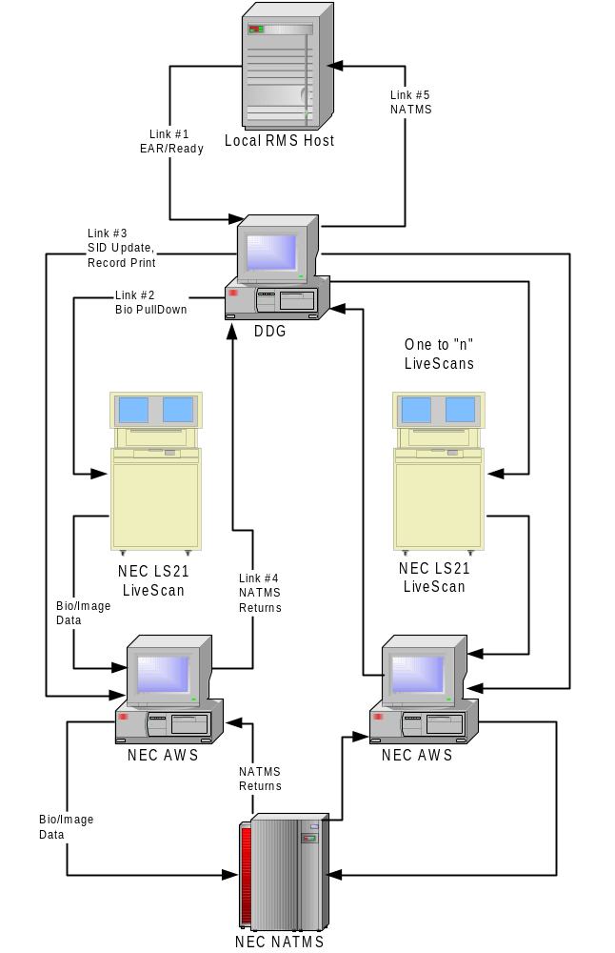

Figure 3 – MULTIPLE LS21 LiveScans WITH AWS in PuLL Down Mode

In another type of system configuration, an NEC Administrative Workstation (AWS) may be added into the data flow between the LS21 and the NATMS. The AWS, based on the Identix Store and Forward, allows central booking data technicians to audit and modify records before their transmission to NATMS. The AWS also provides a record print facility at a different location from the LS21 LiveScan unit.
As shown in Figure 3, the LS21 is configured to pull down biographical data from the DDG. After fingerprint images are acquired, the record is sent to the AWS. At the AWS, the record may be edited before automatic or delayed transmission to the DPS NATMS.
Also shown is a second LS21 and associated AWS units. Up to ten LS21 /AWS pairs may be configured. The actual upper limit of LS21 / AWS units that can be supported by a single DDG is a function of the DDG memory capacity, CPU speed, and allowable response time to data requests.
There are two data flows. The forward path is biographical (or demographic) data flowing from the local RMS host to the DDG. The DDG retains that data until a request arrives from one of the LS21 units. After acquiring the fingerprint images, the LS21 forwards the record to the AWS. Finally, the AWS pushes the biographical data along with the acquired fingerprint images to the NATMS. The reverse path is reports or returns from the NATMS to the AWS. The DDG can optionally be configured to move the NATMS returns from the AWS back to the local RMS host.
Those communication links that are configured on the DDG are as follows:
Link #1 – EAR/Ready. This communication link moves the READY.xxx and EAR.xxx files from the local RMS host to the DDG. It also moves EARACK.xxx files from the DDG back to the local RMS host. This link is configured in the local RMS host configuration notebook (Section 4.2 below).
Link #2 – Bio Pull Down. This communication link allows FCS requests for biographical data to flow from the LS21 to the DDG. It provides biographical data for record creation on the LS21 via the FCS provider located on the DDG. This link is configured in the DDG configuration notebook (Section 4.4 below). This link is configured to access a shared directory on one of the LS21 units. The other LS21 units access this shared directory via NFS.
Link #3 –SID Update, Record Print. This communication link allows FCS requests to flow from the DDG to the AWS. If the reverse channel has been configured for SID Updates and/or Record Print functions, then this link is used transmit the appropriate FCS requests from the DDG to the AWS. This link is configured in the LiveScan / AWS configuration notebook (Section 4.3 below). This link only exists if NATMS returns have been enabled in the LiveScan / AWS configuration notebook.
Link #4 – NATMS Returns. This optional communication link allows the DDG to read the NATMS return messages from the AWS message log. This link is configured in the LiveScan / AWS configuration notebook (Section 4.3 below). This link only exists if NATMS returns have been enabled in the LiveScan / AWS configuration notebook.
Link #5 – NATMS Returns. This optional communication link moves the NATMS return messages from the DDG to the local RMS host. This link is configured in the local RMS host configuration notebook (Section 4.2 below). This link only exists if NATMS returns have been enabled in the LiveScan / AWS configuration notebook.
There is only a single instance of Link #1, Link #2 and Link #5 per DDG. There are as many instances of Link #3 and Link #4 as there are configured and enabled LS21 / AWS pairs. For each LS21 / AWS pair that is added to the configuration, separate instances of these communication links will be created by the DDG.
The links that move the Bio/Image Data from the AWS to the NATMS, and NATMS returns from the NATMS to the AWS, are configured in the AWS.

Operation

All configuration and operations of the DDG server are accomplished through the Windows graphical user interface. A conventional arrangement of menu and graphical controls provide the operator with the means to configure and operate the DDG server.

The DDG Server is started from the Start | Programs menu on the Windows NT desktop. Select the “Texas DDG” menu item from the “Texas DDG” folder.

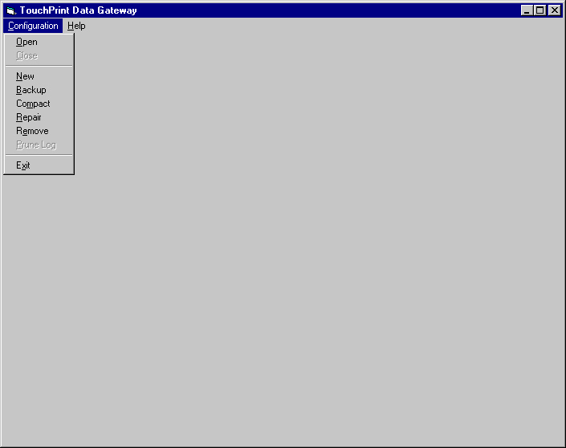

Figure 4 – DDG User Interface at Startup, with Configuration Menu Selections Visible

All DDG configuration data, message logs, and transaction records are stored in a Microsoft Access compatible database file. By selecting a database file, the complete configuration and operating context of the DDG server is established. The Configuration main menu list item provides the operations necessary to manipulate DDG configuration files. As seen in Figure 4, seven configuration menu items are available:

Open – Selects an existing configuration database to open.
Close – Closes any currently open configuration database.
New – Closes any currently open configuration database, builds new empty configuration database, then opens it.
Backup – Performs backup/repair/compaction cycle on a configuration database.
Compact – Closes any currently open configuration database, then compacts selected database file into new database file.
Repair – Closes any currently open configuration database, then attempts to repair a corrupted configuration database file and validate system tables and record indexes.
Remove – Closes any currently open configuration database, then deletes selected database file.
Prune Log – Deletes all but the most recent 500 messages from the message log.
Exit – Closes any currently open configuration database, then exits DDG server.

Creating a New Configuration Database

Use the New menu item from the Configuration main menu item. You will be presented with a standard Windows file selection dialog box. You can choose an existing database file to overwrite, or enter a new configuration file name. Only the file name is required, the file extension “.mdb” will be automatically supplied. If you do enter an extension, then it must be “.mdb”.

Once the configuration file name is established, then the DDG server will create the database file, and populate it with the necessary tables. The DDG User Interface will appear as shown in Figure 5 below.

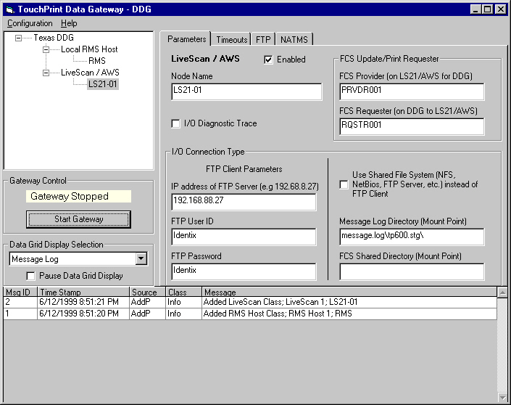

Figure 5 – DDG User Interface after Using “New” Menu Item to Create New Configuration Database

The user interface contains five major elements. In the upper left is a node selection tree. Selecting a node on the tree enables the parameter notebook for the node to appear in the upper right part of the display. The node selection tree operates using the familiar tree selection methods as implemented in the Windows NT Explorer, and other Microsoft products. For example, node groups can be expanded or collapsed by clicking on the + or – signs.

The bottom portion of the user interface contains a data grid, which allows the display and manipulation of various configuration database tables, as selected by the drop down selection box located in the “Data Grid Display Selection” frame (middle right portion of the user interface). Also in the middle right portion of the user interface is the “Gateway Control” frame that includes the gateway status and Start/Stop button.

At this point the configuration contains the DDG node, the local RMS host interface node and one LiveScan / AWS node. Additional nodes can be added by using the mouse to left click on the node class (Local RMS Host or LiveScan / AWS), then right clicking to display the pop up menu with the Add selection. Left clicking on the Add selection then adds the appropriate node type to the configuration database. Exactly local RMS host node is required. One, or as many as ten LiveScan / AWS nodes may be added.

Nodes may be deleted by using the mouse to left click on the node to be deleted, then right clicking to display the pop up menu with the Delete selection. Left clicking on the Delete selection then deletes the node from the configuration database.

The following sections describe the process of configuring the three types of nodes: DDG, local RMS host, and LiveScan / AWS.

Configuring the DDG Node

DDG Node - Parameters Tab

After the DDG node is selected, the Parameters notebook page is displayed on the upper right quadrant of the DDG window. The node name of “Texas DDG” can be changed in the Node Name box.

The rest of the parameters in this notebook, including the Timeouts and FTP tabs are only meaningful if the “FCS Pull Down Enabled” box is checked. This checkbox enables pull down mode for all attached LiveScan / AWS nodes.

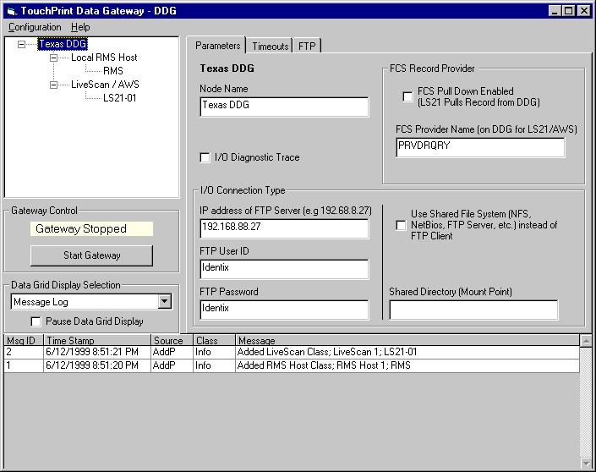

Figure 6 – DDG User Interface after SELECTING DDG Node

The FCS Provider box should be set to match the CREATE_QUERY_FCS_PROVIDER parameter in the configuration files of the associated LiveScan / AWS computers. This is the name of the FCS provider in the DDG that supplies biographical data for pull down to the LS21 LiveScan units.

Next determine the type of communication channel for FCS between the DDG and the LiveScan / AWS. The normal mode of communication is with FTP client on the DDG, FTP server on the LiveScan / AWS. If the communication is to be performed through some variety of shared file system, then click to check the “Use Shared File System (NFS, NetBios, FTP Server, etc.) instead of FTP Client” checkbox. If the channel type is FTP (client on DDG), then leave this checkbox blank.

Fill in the Shared Directory (Mount Point) box with the FCS provider file system path. For FTP client access to the root directory made available by the FTP server on the LiveScan, then this box would be blank. For directories located on the DDG, and shared with the LiveScan, use the full directory path, e.g. C:\IDXRCV. For directories located on the LiveScan, and mounted on the DDG, then the box should be set to something like "g:\” where “g:” represents the drive letter of the NFS mount point.

If the system contains multiple LiveScans and the normal FTP client access by the DDG is to be used, then locate the FCS provider directory on one of the LiveScan / AWS units, then use FTP server on that unit to provide access to the DDG. Use NFS to provide access to that directory for other LiveScan units. The FCS provider directory will normally be the same as the FCS requester directory on the LiveScan unit chosen to host the FCS provider directory.

The CREATE_QUERY_FCS_DIRECTORY parameter in the configuration files of the associated LiveScan / AWS computers must all be identically set to the location of the FCS provider directory that you have chosen. This directory path must also be set into the read and write directories of the TRUSER section of the FTP server tab of the TCP/IP configuration notebook of the LS21 hosting the FCS provider directory.

The CREATE_QUERY_REQUESTER parameter in the configuration files of the associated LiveScan / AWS computers must all be unique to identify which LS21 is making the pull down request. This parameter should be set to the same value as the FCS_REQUESTER_NAME parameter for that LS21.

If the normal FTP client access by the DDG is to be used, then three other boxes on the parameter notebook tab need to be set.

The “IP Address of FTP Server” box is set to the address of the FTP server on the LiveScan hosting the FCS provider directory, and may utilize an absolute IP address or domain name if DNS is available.

The FTP server on the LiveScan / AWS does not allow write access for anonymous logins so a user ID and password login is mandatory for FCS with FTP client. The FTP User ID and FTP Password must be set to correspond with those entered in the TRUSER section on the Services tab of the TCP Configuration Notebook in the OS/2 TCP/IP folder.

The I/O diagnostic trace checkbox can be filled to cause a detailed trace of all FCS transactions for this node. This checkbox should normally be cleared, since the diagnostic trace generates a large volume of messages in the message log.

DDG Node - Timeouts Tab

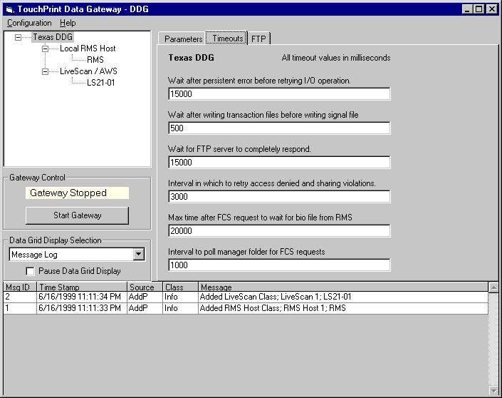

Figure 7 – DDG User Interface after Selecting the Timeouts Tab for A DDG Node

The FCS feature of TouchPrint is in essence a data communications protocol and as such requires various error detection and retry mechanisms involving timeouts. The values of these timeouts are adjustable and specified on the Timeouts Tab in units of milliseconds. The timeout values apply only to the selected node. The default timeout values are shown above in Figure 7.

The “Wait after persistent error before retrying I/O operation.” timeout provides an idle interval after a persistent error before rescheduling another attempt to perform the I/O operation. For best performance, this value should not be set for less than 5 seconds

The “Wait after writing transaction files before writing signal file.” timeout provides a short interval between the completion of the DDG writing the requested biographical data files and the writing of the request complete signal files (.rs0 or .ss0). Accommodates occasional file system or file redirector timing or race issues.

The “Wait for FTP server to completely respond.” Timeout provides an interval to allow for FTP server processing of an FTP client request. For best performance, this value should not be set for less than 5 seconds.

The “Interval in which to retry access denied and sharing violations.” Provides an interval during which operations that signal errors are retried. On occasion, directories and files involved in the FCS provider transaction are being accessed by the other computers and access attempts by the DDG will be blocked. These lockout conditions are normally only present for less than two seconds, so retrying the operation can allow the FCS provider transaction to proceed. This timeout value should not be set for less than 3 seconds. If an error condition is still present after this timeout period, then activity on this node ceases for the time interval set by the “Wait after persistent error before retrying I/O operation” interval described above.

The “Max time after FCS request to wait for bio file from RMS.” timeout provides the maximum time interval to wait for the bio file from the RMS. If this timeout expires before the RMS supplies the bio file, then the FCS provider terminates the request with an error status file (submit.stt) return. The contents of the status file is two lines:

1 REJECTED
[external:1] 1 TRN #: nnnnnnnnnn was not found on DDG

The “Interval to poll manager folder for FCS requests.” timeout provides the polling interval for checking for incoming FCS requests or for checking for arrival of the bio file from the RMS. This value should not be less than 1 second, nor more than half of the “Max time after FCS request to wait for bio file from RMS” value.

DDG Node - FTP Tab

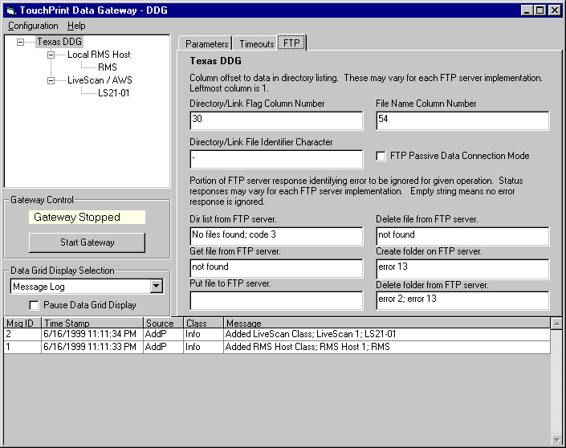

Figure 8 – DDG User Interface after Selecting the FTP Tab for a DDG Node

The FTP tab contains a set of parameters that customize the FTP client in the DDG to a particular FTP server. Although FTP servers generally conform to the specification RFC 959 – File Transfer Protocol (FTP), there are variations between FTP servers that require adjustments by the FTP client.

Suggested values for the parameters on this tab for various types of FTP servers are given in Appendix B of this document.

The “Directory/Link Flag Column Number” is the column number of the character in the DIR list FTP command that indicates a line describing a file, rather than a line describing a directory or link.

The “Directory/Link File Identifier Character” is the value of the character in the DIR list FTP command that indicates a line describing a file, rather than a line describing a directory or link.

The “File Name Column Number” is the column number of the start of the file name in the DIR list FTP command

The “FTP Passive Data Connection Mode” checkbox enables FTP passive mode. This box causes the FTP client to use passive data connections for those few FTP servers requiring that mode.

The DDG FTP client uses six types of FTP commands. These FTP commands may return an error response that is anticipated, and therefore that particular error response should not trigger a retry attempt but rather serve as a status response.

Error responses may vary for each FTP server implementation, and the FTP tab provides a way to adjust for varying FTP server implementations. The default strings established when the DDG configuration is created are for the OS/2 FTP server. An empty string in a field means that no error response is treated as a status response.

The string is only that portion of the full FTP server response that uniquely identifies a particular status. The full FTP server responses under any conditions can be observed using the standard Windows NT command line FTP client. These strings only apply if FTP client, rather than a shared file system is used as the communication channel for FCS. Several different responses to a command may be designated as status responses. The semicolon character separates each string in the parameter block, and leading and trailing blanks are trimmed from the string before the comparison with the FTP command response is done.

The “Dir list from FTP server” string identifies the response when the FTP server cannot locate the file or path requested with an FTP DIR command.

The “Get file from FTP server” string identifies the response when the FTP server cannot locate the file requested with an FTP GET command.

The “Put file to FTP server.” string identifies the response when the file on the server to be created with an FTP PUT command already exists. FTP servers typically overwrite an existing file without complaint, so this field is blank by default.

The “Delete file from FTP server.” string identifies the response when the FTP server cannot locate the file requested with an FTP DELETE command.

The “Create folder on FTP server.” string identifies the response when the folder on the server to be created with an FTP MKDIR already exists. Error 13 is the OS/2 control program error code for “ERROR_INVALID_DATA”.

The “Delete folder from FTP server.” string identifies the response when the FTP server cannot locate the folder requested with an FTP RMDIR command. Error 2 is the OS/2 control program error code for “ERROR_FILE_NOT_FOUND”.

Configuring the Local RMS Host Node

Local RMS Host - Parameters Tab

After the Local RMS Host is selected, the Parameters notebook page is displayed on the upper right quadrant of the DDG window. The node name of “RMS” can be changed in the Node Name box.

The rest of the parameters in this notebook, including the Timeouts and FTP tabs are only meaningful if the “Enabled” box is checked. This checkbox enables DDG access to the local RMS host.

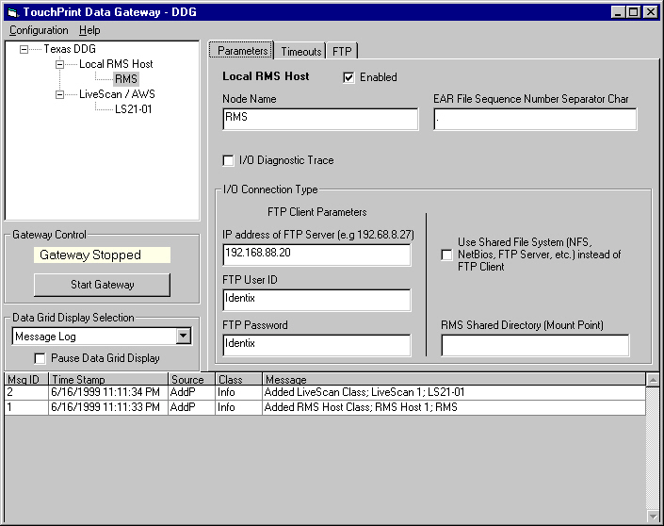

Figure 9 – DDG User Interface after SELECTING Local RMS Host

The “EAR File Sequence Number Separator Char” box normally contains the period “.” character. If an IBM AS/400 is used as the local RMS host, then this parameter must be changed to a “_“ (underscore) character. This allows the FTP client in the DDG to accommodate the special file structure requirements of the IBM AS/400. Further details are located in Appendix B – FTP Configuration.

Next determine the type of communication channel for FCS between the DDG and the local RMS host. The normal mode of communication is with FTP client on the DDG, FTP server on the local RMS host. If the communication is to be performed through some variety of shared file system, then click to check the “Use Shared File System (NFS, NetBios, FTP Server, etc.) instead of FTP Client” checkbox. If the channel type is FTP (client on DDG), then leave this checkbox blank.

Fill in the “RMS Shared Directory (Mount Point)” box with the local RMS host file system path. For FTP client access to the root directory made available by the FTP server on the local RMS host, then this box would be blank. For directories located on the DDG, and shared with the local RMS host, use the full directory path, e.g. C:\LSDATA. For directories located on the local RMS host, and mounted on the DDG, then the box should be set to something like "g:\” where “g:” represents the drive letter of the NFS mount point.

If the normal FTP client access by the DDG is to be used, then three other boxes on the parameter notebook tab need to be set.

The “IP Address of FTP Server” box is set to the address of the FTP server on the local RMS host with the LSDATA directory, and may utilize an absolute IP address or domain name if DNS is available.

The FTP server on the local RMS host may not allow write access for anonymous logins so a user ID and password login is mandatory. The FTP User ID and FTP Password must be set to correspond with those entered in the FTP server on the local RMS host.

The I/O diagnostic trace checkbox can be filled to cause a detailed trace of all communication I/O transactions for this node. This checkbox should normally be cleared, since the diagnostic trace generates a large volume of messages in the message log.

Local RMS Host - Timeouts Tab

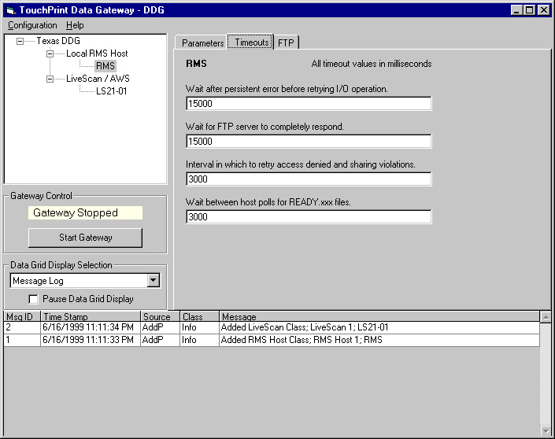

Figure 10 – DDG User Interface after Selecting the Timeouts Tab for A Local RMS Host

Access to the local RMS host LSDATA directory is in essence a data communications protocol and as such requires various error detection and retry mechanisms involving timeouts. The values of these timeouts are adjustable and specified on the Timeouts Tab in units of milliseconds. The timeout values apply only to the selected node. The default timeout values are shown above in Figure 10.

The “Wait after persistent error before retrying I/O operation.” timeout provides an idle interval after a persistent error before rescheduling another attempt to perform the I/O operation. For best performance, this value should not be set for less than 5 seconds

The “Wait for FTP server to completely respond.” Timeout provides an interval to allow for FTP server processing of an FTP client request. For best performance, this value should not be set for less than 5 seconds.

The “Interval in which to retry access denied and sharing violations.” Provides an interval during which operations that signal errors are retried. On occasion, directories and files involved in the local RMS host transaction are being accessed by the other computers and access attempts by the DDG will be blocked. These lockout conditions are normally only present for less than two seconds, so retrying the operation can allow the local RMS host transaction to proceed. This timeout value should not be set for less than 3 seconds. If an error condition is still present after this timeout period, then activity on this node ceases for the time interval set by the “Wait after persistent error before retrying I/O operation” interval described above.

The “Wait between host polls for READY.xxx files.” timeout provides the polling interval for checking for new or different READY.xxx files. This value should not be less than 1 second.

Local RMS Host - FTP Tab

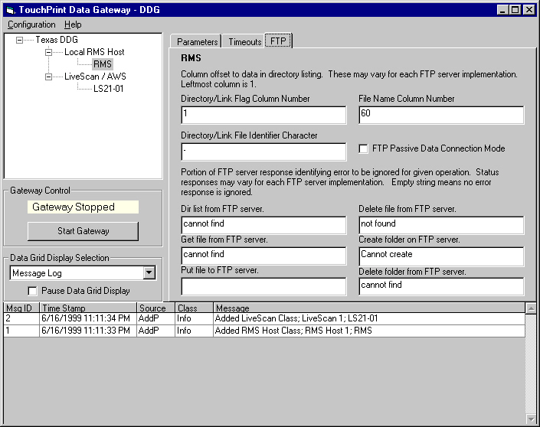

Figure 11 – DDG User Interface after Selecting the FTP Tab for a Local RMS Host

The FTP tab contains a set of parameters that customize the FTP client in the DDG to a particular FTP server. Although FTP servers generally conform to the specification RFC 959 – File Transfer Protocol (FTP), there are variations between FTP servers that require adjustments by the FTP client.

Suggested values for the parameters on this tab for various types of FTP servers are given in Appendix B of this document.

The “Directory/Link Flag Column Number” is the column number of the character in the DIR list FTP command that indicates a line describing a file, rather than a line describing a directory or link.

The “Directory/Link File Identifier Character” is the value of the character in the DIR list FTP command that indicates a line describing a file, rather than a line describing a directory or link.

The “File Name Column Number” is the column number of the start of the file name in the DIR list FTP command

The “FTP Passive Data Connection Mode” checkbox enables FTP passive mode. This box causes the FTP client to use passive data connections for those few FTP servers requiring that mode.

The DDG FTP client uses six types of FTP commands. These FTP commands may return an error response that is anticipated, and therefore that particular error response should not trigger a retry attempt but rather serve as a status response.

Error responses may vary for each FTP server implementation, and the FTP tab provides a way to adjust for varying FTP server implementations. The default strings established when the DDG configuration is created are for the OS/2 FTP server. An empty string in a field means that no error response is treated as a status response.

The string is only that portion of the full FTP server response that uniquely identifies a particular status. The full FTP server responses under any conditions can be observed using the standard Windows NT command line FTP client. These strings only apply if FTP client, rather than a shared file system is used as the communication channel for FCS. Several different responses to a command may be designated as status responses. The semicolon character separates each string in the parameter block, and leading and trailing blanks are trimmed from the string before the comparison with the FTP command response is done.

The “Dir list from FTP server” string identifies the response when the FTP server cannot locate the file or path requested with an FTP DIR command.

The “Get file from FTP server” string identifies the response when the FTP server cannot locate the file requested with an FTP GET command.

The “Put file to FTP server.” string identifies the response when the file on the server to be created with an FTP PUT command already exists. FTP servers typically overwrite an existing file without complaint, so this field is blank by default.

The “Delete file from FTP server.” string identifies the response when the FTP server cannot locate the file requested with an FTP DELETE command.

The “Create folder on FTP server.” string identifies the response when the folder on the server to be created with an FTP MKDIR already exists. Error 13 is the OS/2 control program error code for “ERROR_INVALID_DATA”.

The “Delete folder from FTP server.” string identifies the response when the FTP server cannot locate the folder requested with an FTP RMDIR command. Error 2 is the OS/2 control program error code for “ERROR_FILE_NOT_FOUND”.

Configuring the LS21 / AWS Node

LS21 / AWS - Parameters Tab

After the LS21 / AWS is selected, the Parameters notebook page is displayed on the upper right quadrant of the DDG window. The node name of “LS21-01” can be changed in the Node Name box.

The rest of the parameters in this notebook, including the Timeouts and FTP tabs are only meaningful if the “Enabled” box is checked. This checkbox enables DDG access to this LS21 / AWS unit or pair.

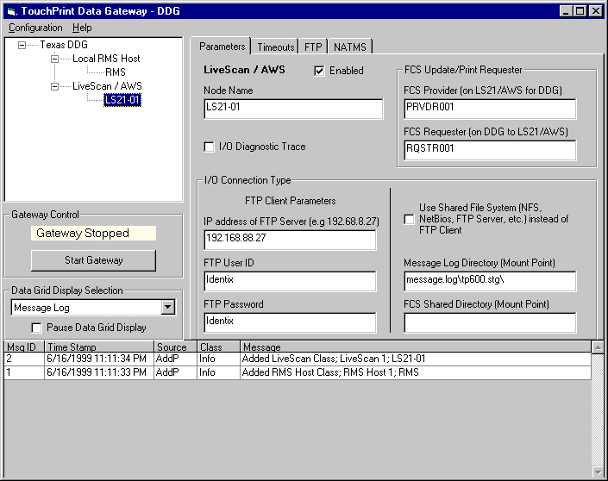

Figure 12 – DDG User Interface after SELECTING LS21 / AWS

The FCS Provider and FCS Requester boxes should be set to names matching the FCS_PROVIDER_NAME and FCS_REQUESTER_NAME entries in the configuration file of the associated LiveScan / AWS computer.

Next determine the type of communication channel for FCS between the DDG and the LS21 / AWS. The normal mode of communication is with FTP client on the DDG, FTP server on the LS21 / AWS. If the communication is to be performed through some variety of shared file system, then click to check the “Use Shared File System (NFS, NetBios, FTP Server, etc.) instead of FTP Client” checkbox. If the channel type is FTP (client on DDG), then leave this checkbox blank.

Fill in the FCS Shared Directory (Mount Point) box with the FCS file system path given in the FCS_FS_DIRECTORY entry in the configuration file of the associated LiveScan / AWS computer. For FTP client access to the root directory made available by the FTP server on the LS21 / AWS, then this box would be blank. For directories located on the LS21 / AWS, and mounted on the DDG, then the box should be set to something like "g:\” where “g:” represents the drive letter of the NFS mount point.

For directories located on the DDG, and shared with the LS21 / AWS, use the full directory path, e.g. C:\IDXRCV. Be sure to copy the prototype FCS file structure that includes the “services.cvt” and related files from the LS21 or AWS to the DDG before attempting to start the DDG gateway, or errors will be logged.

In a similar vein, fill in the “Message Log Directory (Mount Point)”. This is the path to the message log backup directory, typically “message.log\tp600.stg” that contains the backup copies of the LS21 / AWS message log. The DDG looks here for messages returned from the NATMS. The MSG_LOG_DIRECTORY entry in the configuration file of the associated LiveScan / AWS computer points to the message log directory, and the backup directory is one level lower in the tree. If the MSG_LOG_DIRECTORY entry is “c:\message.log\” then in the “Message Log Directory (Mount Point)” would contain “message.log\tp600.stg\”

If the normal FTP client access by the DDG is to be used, then three other boxes on the parameter notebook tab need to be set.

The “IP Address of FTP Server” box is set to the address of the FTP server on the LS21 / AWS with the LSDATA directory, and may utilize an absolute IP address or domain name if DNS is available.

The FTP server on the LS21 / AWS may not allow write access for anonymous logins so a user ID and password login is mandatory. The FTP User ID and FTP Password must be set to correspond with those entered in the FTP server on the LS21 / AWS.

The I/O diagnostic trace checkbox can be filled to cause a detailed trace of all communication I/O transactions for this node. This checkbox should normally be cleared, since the diagnostic trace generates a large volume of messages in the message log.

LS21 / AWS - Timeouts Tab

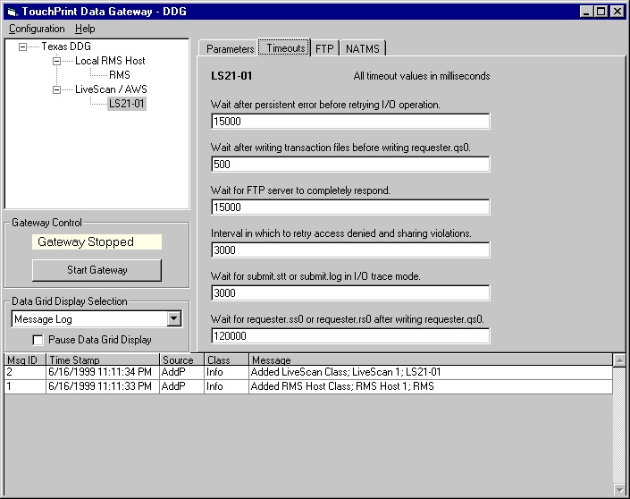

Figure 13 – DDG User Interface after Selecting the Timeouts Tab for A LS21 / AWS

The FCS feature of TouchPrint is in essence a data communications protocol and as such requires various error detection and retry mechanisms involving timeouts. The values of these timeouts are adjustable and specified on the Timeouts Tab in units of milliseconds. The timeout values apply only to the selected node. The default timeout values are shown above in Figure 13.

The “Wait after persistent error before retrying I/O operation” timeout provides an idle interval after a persistent error before rescheduling another attempt to perform the I/O operation. For best performance, this value should not be set for less than 5 seconds

The “Wait after writing transaction files before writing requester.qs0.” timeout provides a short interval between the completion of the DDG writing the request data files and the writing of the request signal file. Accommodates occasional file system or file redirector timing or race issues.

The “Wait for FTP server to completely respond.” Timeout provides an interval to allow for FTP server processing of an FTP client request. For best performance, this value should not be set for less than 5 seconds.

The “Interval in which to retry access denied and sharing violations.” Provides an interval during which operations that signal errors are retried. On occasion, directories and files involved in the FCS transaction are being accessed by the other computers and access attempts by the DDG will be blocked. These lockout conditions are normally only present for less than two seconds, so retrying the operation can allow the FCS transaction to proceed. This timeout value should not be set for less than 3 seconds. If an error condition is still present after this timeout period, then activity on this node ceases for the time interval set by the “Wait after persistent error before retry” interval described above.

The “Wait for submit.stt or submit.log in I/O trace mode.” timeout provides the maximum time interval to wait for the submit status or log files from the FCS server when in I/O diagnostic trace mode. When not in I/O diagnostic trace mode, this timeout value is treated as zero, and only one check for the files will be made. Accommodates occasional delays between the FCS server writing the signal file(s) and the FCS server writing the submit status and/or log files.

The “Wait for requester.ss0 or requester.rs0 after writing requester.qs0.” timeout provides the maximum time interval wait for the LS21 / AWS to respond to an update service request. For a variety of reasons, an FCS request may be “missed” by the LS21 / AWS. This timeout breaks the deadlock condition, erases the existing request and resubmits the FCS request.

LS21 / AWS - FTP Tab

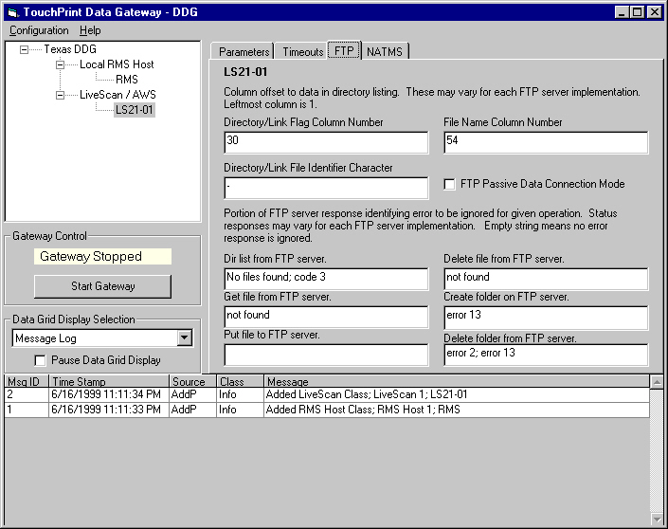

Figure 14 – DDG User Interface after Selecting the FTP Tab for a LS21 / AWS

The FTP tab contains a set of parameters that customize the FTP client in the DDG to a particular FTP server. Although FTP servers generally conform to the specification RFC 959 – File Transfer Protocol (FTP), there are variations between FTP servers that require adjustments by the FTP client.

Suggested values for the parameters on this tab for various types of FTP servers are given in Appendix B of this document.

The “Directory/Link Flag Column Number” is the column number of the character in the DIR list FTP command that indicates a line describing a file, rather than a line describing a directory or link.

The “Directory/Link File Identifier Character” is the value of the character in the DIR list FTP command that indicates a line describing a file, rather than a line describing a directory or link.

The “File Name Column Number” is the column number of the start of the file name in the DIR list FTP command

The “FTP Passive Data Connection Mode” checkbox enables FTP passive mode. This box causes the FTP client to use passive data connections for those few FTP servers requiring that mode.

The DDG FTP client uses six types of FTP commands. These FTP commands may return an error response that is anticipated, and therefore that particular error response should not trigger a retry attempt but rather serve as a status response.

Error responses may vary for each FTP server implementation, and the FTP tab provides a way to adjust for varying FTP server implementations. The default strings established when the DDG configuration is created are for the OS/2 FTP server. An empty string in a field means that no error response is treated as a status response.

The string is only that portion of the full FTP server response that uniquely identifies a particular status. The full FTP server responses under any conditions can be observed using the standard Windows NT command line FTP client. These strings only apply if FTP client, rather than a shared file system is used as the communication channel for FCS. Several different responses to a command may be designated as status responses. The semicolon character separates each string in the parameter block, and leading and trailing blanks are trimmed from the string before the comparison with the FTP command response is done.

The “Dir list from FTP server” string identifies the response when the FTP server cannot locate the file or path requested with an FTP DIR command.

The “Get file from FTP server” string identifies the response when the FTP server cannot locate the file requested with an FTP GET command.

The “Put file to FTP server.” string identifies the response when the file on the server to be created with an FTP PUT command already exists. FTP servers typically overwrite an existing file without complaint, so this field is blank by default.

The “Delete file from FTP server.” string identifies the response when the FTP server cannot locate the file requested with an FTP DELETE command.

The “Create folder on FTP server.” string identifies the response when the folder on the server to be created with an FTP MKDIR already exists. Error 13 is the OS/2 control program error code for “ERROR_INVALID_DATA”.

The “Delete folder from FTP server.” string identifies the response when the FTP server cannot locate the folder requested with an FTP RMDIR command. Error 2 is the OS/2 control program error code for “ERROR_FILE_NOT_FOUND”.

LS21 / AWS - NATMS Tab

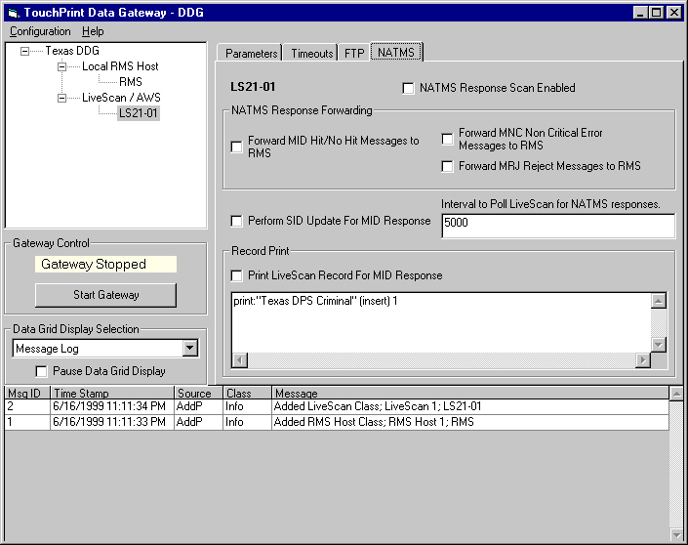

Figure 15 – DDG User Interface after Selecting the NATMS Tab for a LS21 / AWS

The NATMS tab contains a set of parameters that customize NATMS return processing for this LS21 / AWS.

The rest of the parameters in this notebook tab are only meaningful if the “NATMS Response Scan Enabled” box is checked. This checkbox enables DDG access to this LS21 / AWS unit or pair for NATMS return messages.

The “Interval to Poll LiveScan for NATMS responses” parameter establishes the polling interval for checking for new NATMS return messages.

The “NATMS Response Forwarding” frame controls which types of NATMS return messages will be returned to the local RMS host in the directory path established by the “RMS Shared Directory (Mount Point)” parameter box in the Local RMS Host node Parameters tab.

NATMS return message types MID, MNC, and MRJ can be selected for return to the local RMS host. NATMS return message types MAD, MAC, and MFI cannot be returned to the local RMS host because these message types do not include the TRN number, which forms part of the file name when written to the local RMS host.

The “Perform SID Update For MID Response” enables SID update to a record on the LS21 /AWS when an MID NATMS response is received by the LS21 or AWS.

A record print operation can be performed on the LS21 / AWS when an MID response is received from the NATMS if the “Print LiveScan Record For MID Response” box is checked. The print request can be adjusted in the associated “Record Print” text box.

The record key is the TRN number, and the submit.req file contains two or more lines. The first line is always "record (locate) record.key", and further lines are as provided in the “Record Print” text box.

Data Grid Display

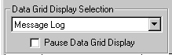
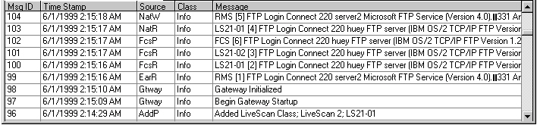

Figure 16 – DATA GRID DISPLAY

The bottom portion of the DDG user interface includes a data grid displaying the message log or other selected database tables in real time. The entries are displayed in reverse chronological order, so that the latest entry appears on top of the display. The display is updated automatically twice a second as messages are logged or records are added to a database table.

The operator may scroll through the messages or table entries using the scroll bar on the right side of the screen, however, the display will automatically revert to the most recent message whenever a new message is logged. Logging activity can be temporarily suspended by enabling the “Pause Data Grid Display” checkbox, or by stopping the gateway.

The data grid can display five different types of data, and the selection displayed is made with the drop down selection box in the “Data Grid Display Selection” frame immediately above the data grid on the left side. The selections for display are:

1. Message Log
- EAR/Ready Files
- NATMS Files
- FCS Queue
- NATMS Queue

A description of these tables and their relationship with system processes is available below in Section 5.2 - Data and Process Relationships.

Whenever a configuration file is opened, the size of the message log is checked. If there are more than 500 entries, then the message log is pruned to the latest 500 entries. Pruning many hundreds or thousands of message log entries can take an extended period of time, during which the hourglass cursor is displayed.

The message text field of a message log entry can be quite large, several hundred characters, and may contain CR/LF line terminators. To view the entire contents of the message text field, click on the desired message in the data grid, and a text box displaying the entire message will appear on the upper right portion of the DDG window. The configuration notebook, which initially occupies that space can be redisplayed by clicking on the desired node in the node tree (upper left portion of the DDG window).

Clicking on the top message in the message log will cause text box to be updated automatically as messages are added to the log, even when viewing another table in the data grid.

Refer to Appendix A for a detailed description of message log record types and field contents.

When the data grid is used to display a database table other than the message log, records can be deleted by double clicking the record of interest in the data grid. A message box will pop up identifying the record to be deleted, and asking for operator confirmation before deletion.

Deleting a record from the EAR/Ready Files or NATMS Files tables will allow the DDG to rescan for that file name for processing. This allows another opportunity to process a file, if for some rare occurrence the results from the first attempt were lost in transmission.

Deleting a record from the FCS Queue or NATMS Queue may be desirable if a validation error cannot be resolved by the LiveScan.

Starting and Stopping the Gateway

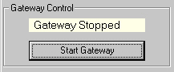

Figure 17 – DDG Gateway Control Panel

The DDG gateway control panel contains the gateway status display, and a button to start and stop the gateway. A wide variety of checks are performed before gateway can be started. Examples of some of these checks are:

- A DDG configuration file must be currently open.
- A local RMS host node must be defined and enabled.
- At least one LS21 / AWS node must be defined and enabled.
- The FCS provider folder for use by the DDG FCS requester must be present; the DDG does not attempt to create it.
- The files “services” and “working” must be present in the FCS provider folder.
- DDG must be able to create the manager folder if not already present.
- DDG must be able to create the requester folder if not already present.

While these checks are being performed the gateway status display changes from “Gateway Stopped” to “Gateway Starting”. When the checks have been successfully completed, the gateway status display changes from “Gateway Starting” to “Gateway Started”.

If any of these checks fail, a message dialog box will inform the operator of the problem. Once these checks are passed, the “Gateway Stopped” status bar changes to “Gateway Running” and a “Started gateway” message appears in the message log. These checks may take a short period of time to complete.

Once the gateway is in startup mode or is started, the button caption changes to “Stop Gateway”. The button may be then be used to stop gateway operation. The gateway is shut down in an orderly fashion. Any FCS requester transaction in progress will be halted, and will be resubmitted when the gateway is restarted. Any partially processed EAR/Ready files will complete their processing when the gateway is restarted. During the shutdown process the gateway status display changes from “Gateway Stopped” to “Gateway Stopping”.

The shutdown process may take a short period of time to complete. Once the gateway shutdown is complete, the button caption changes to “Start Gateway”, the “Gateway Stopping” status bar changes to “Gateway Stopped” and a “Stopped gateway” message appears in the message log.

When the gateway is stopped, the configuration notebook is enabled for changing parameters.

Gateway Data Processing

System Workflow

The general system workflow from the local RMS host, through the DDG, LS21 to the NATMS and return is illustrated below in Figure 18 – System Process Flow for Baseline DDG Implementation.
The booking process originates at the local RMS host. The host will send an EAR formatted file containing the booking data to the DDG in “push down” mode by placing it in the “lsdata” common directory. The host then places the associated READY signal file in the common directory. The DDG polls for the READY file, and will then process the EAR file, check it for errors and place in local DDG storage.
The DDG will signal that its initial processing is complete by placing an EARACK file in the common “lsdata” directory. The host then deletes all files (EAR, READY and EARACK) associated with that booking record from the shared “lsdata” directory.
If the DDG initial processing detects no errors, the booking data is converted to “b.txt” format. If only a single LiveScan (LS-21 or AWS) is attached to the DDG, then the DDG moves the booking data to the LiveScan by doing a “push down” FCS transaction to the LiveScan. If there are two or more LiveScans attached to the DDG, then the DDG waits for an FCS request from the LiveScan to move the booking data to the LiveScan.
The LiveScan then performs the fingerprint acquisition and transmits the full record to the NEC AFIS. The LiveScan forwards the NEC AFIS (NATMS) response to the DDG. And finally the DDG will post NATMS responses in the common directory structure “lsdata” for processing and removal by the local host, if configured to do so.
If the NATMS response is a SID update, then the DDG will also perform a record update on the LiveScan, and schedule the record for printing on the LiveScan.
An Administrative Workstation (AWS, a version of store/forward) may be in the data channel between the LiveScan and the AFIS. If so, the record update and initiation of card printing will occur on the AWS rather than the LiveScan.

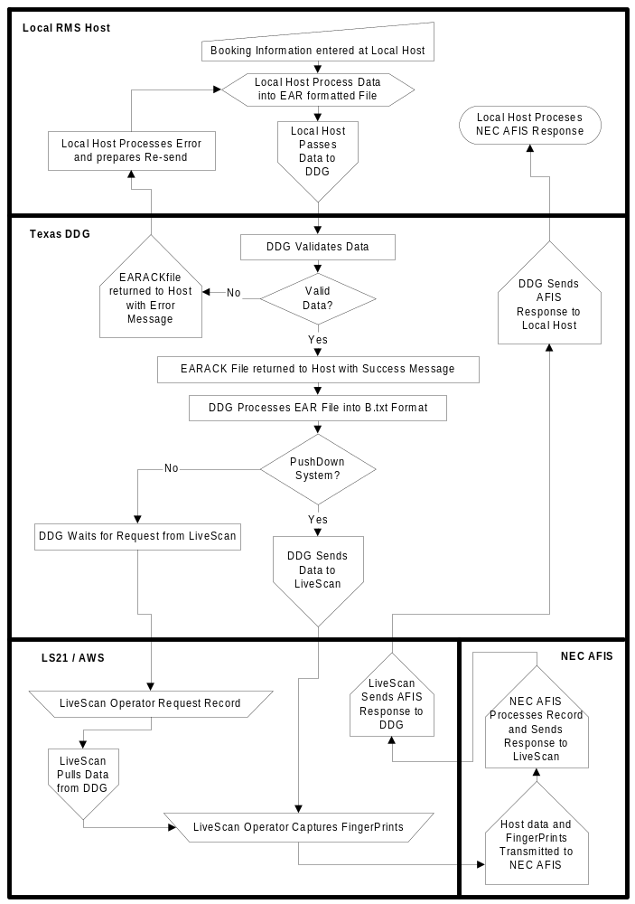
Figure 18 – System Process Flow for Baseline DDG Implementation

Data and Process Relationships

The general relationships between the various processes file structures, and database tables involved in implementing the system workflow are illustrated below in Figure 19 – System Process Flow for Baseline DDG Implementation.
The actual names and locations of the file system directories, such as LSDATA, IDXRCV, and MESSAGE.LOG are configurable. The local RMS host may choose to implement the EAR file writer and NATMS return reader as a single program, or as multiple processes. The database contains additional tables beyond what are illustrated. The database is locked for the exclusive use of the DDG when the DDG program is running.
The DDG program consists of a standard Microsoft Windows graphical user interface (GUI) operating in the foreground. The GUI allows visibility and editing for the node tables: DDG Node, RMS Node, and LiveScan Nodes.
In the background, operating in preemptive multitasking mode, are collections of processes or daemons that act in parallel to implement the various functions of the DDG. A basic set of processes is established when the DDG started, and further processes may be started as a function of configuration when multiple LS21 LiveScan units are attached to the DDG in pull down mode.
The background processes illustrated, and their basic functions are:
- Gateway Monitor – Supervises the orderly startup and shutdown of the gateway. Coordinates the other background processes during startup and shutdown.
- Data Grid Display Update – Periodically updates the display of records in the data grid from current data in the database.
- EAR File Reader – Monitors the collection of READY.xxx files in the LSDATA directory and processes the related EAR.xxx files. Does preliminary data validation on the EAR data file, converts to LS21 format and stores the result in the FCS queue. Stores processing status information in the “EAR/Ready Files” group of tables in the database.
- FCS Requester – Monitors the FCS queue for SID update, or record print requests. Also processes record creation requests if DDG is operating in push down mode.
- FCS Provider – Processes CJIS query record creation requests from LS21 when DDG is operating in pull down mode.
- NATMS Reader – Monitors the collection of files in the MESSAGE.LOG\TP600.STG directory for NATMS returns. Stores SID update and/or record print requests in the FCS queue for NATMS ID returns. Stores NATMS return in NATMS queue. Stores processing status information in the “NATMS Files” table in the database
- NATMS Writer – Monitors the NATMS queue for NATMS returns that will be copied as files to the LSDATA directory on the local RMS host.

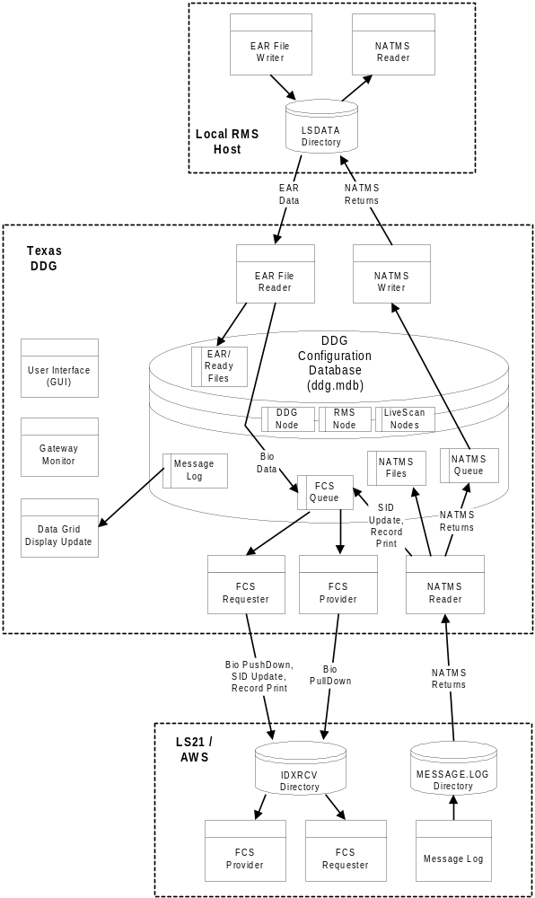

Figure 19 – PROcess and data organization

Local RMS Host Communication Interface

The DDG will communicates with the local RMS host via FTP or NFS over TCP/IP Ethernet. The DDG will normally use a single Ethernet or token ring adapter board to connect to the host and to the LiveScan(s) via FTP client. A separate adapter board for host RMS connection is available as an option.
There are four general ways the DDG can be connected to the RMS host:
- FTP Server on RMS Host, "lsdata" directory on RMS Host. DDG accesses EAR records using the FTP client. This is usually the simplest method from the host RMS programming and support point of view.

- FTP Client on RMS Host, "lsdata" directory on DDG. RMS accesses EAR records using FTP client supplied by/for host RMS computer vender. FTP Server on DDG is the standard FTP Server included with Microsoft Windows NT 4.0 Workstation.

- NFS Server on RMS Host, "lsdata" directory on RMS Host. DDG accesses EAR records using Interdrive v5.0 NFS client (NetManage/FTP third party).

- NFS Client on RMS Host, "lsdata" directory on DDG. RMS accesses EAR records using NFS client supplied by/for host RMS computer vendor. NFS Server on DDG is Interdrive Server 2.0 (NetManage/FTP third party).

The responsibility for removing the EAR, READY and EARACK files is always up to the host RMS. The DDG never removes these files. Although the host RMS should regularly remove these files, the DDG is designed for correct operation if the host RMS chooses not to delete these files:

- If the host does not remove these files, then they will accumulate up to a maximum of 1000 sets of files. The specification allows for a three digit extension for a maximum of 1000 unique file sets. Each set of files occupies less than 2,000 bytes on the average. The maximum space occupied on the RMS or DDG disk if these files are not deleted by the RMS will then be less than 2 megabytes, and should pose no resource problems.

- The DDG tracks the TRN number of all EAR files processed. It will process an EAR file if the TRN is not in the DDG database of TRN numbers. The extension number (the "xxx" in "READY.xxx") is only used to associated the files in a set. The TRN number in the READY.xxx file is used for tracking the transaction from the RMS to the LS21/AWS, and then the NATMS return from the LS21/AWS back to the RMS host. The NATMS return function can be disabled during configuration. The TRN number must be unique for this design to operate correctly. READY.xxx files containing duplicate TRN numbers will be logged as errors.

- The DDG will overwrite any existing EARACK.xxx or NATMS return file in the "lsdata" directory without any error indication.

- The DDG will retain data in it's database regarding a transaction until the transaction has been sent to the LS21/AWS and the associated READY.xxx file has been deleted by the HOST RMS (or overwritten with a different TRN number). Once these two conditions have been met, the DDG will delete the TRN and all associated data from the DDG database. If the TRN is removed from the database by this method, or by operator intervention using the data grid display on the DDG, then a READY.xxx file using this TRN will be again processed by the DDG in the normal manner.

LiveScan Connection Architecture

Using the Identix File Communications Protocol (FCS) will support the LiveScan connections to the DDG. This FCS protocol uses either FTP or NFS (as a configurable option) over TCP/IP as a file exchange mechanism. When using FCS with FTP, the DDG acts as FTP client to the LiveScan FTP Server.

File Transfer Interface – Local RMS Host with DDG

The File Transfer Interface is a file-based process. Both the DDG and the Host will write signal files. The TRN number is the key value used in these interfaces. There are four file types used in this process:

- EAR.nnn
- READY.nnn
- EARACK.nnn
- <trn>.mxx (NATMS message files)

These files are described in detail below.

EAR File

The EAR file is the first file written by the Host. It is written to the "lsdata" shared directory. The filename will be "EAR.nnn”, where “nnn” is an arbitrary sequence number assigned by the Host. This number is also what is used to tie the EAR file to the READY.nnn and EARACK.nnn files. For the IBM AS/400, the naming convention is changed (see Appendix B – FTP Configuration).
The file naming convention for the AS/400 conflicts with the DDG baseline specification. Normally an EAR file would have a file name of EAR.nnn where nnn is a serial number, for example EAR.001. On the AS/400, the .001 would be considered a member name, and a numeric member name is not allowed. So the file naming convention is modified for AS/400 use. Instead of using EAR.001, use EAR_001.EAR_001. The file and member names are then the same, with the serial number in both names after an underscore character.
The AS/400 supports a number of file structures, ranging from Unix and Windows NT compatible file systems to historical file structures compatible with earlier System 34/36/38 systems such as QSYS.LIB.
In the QSYS.LIB file structure, a "library" is equivalent to directory or path, "object" is equivalent to a file name, and "object type" or “member name” is equivalent to a file extension. The object type is more restrictive than an extension, and may not start with numerics.
To resolve this, the DDG has a mode to include support for an EAR file separator that is not the "." (period) character. This separator can be configured on the RMS host configuration notebook as "EAR File Sequence Number Separator Char", and for the AS/400 this should be changed from the default "." (period) to a "_" (underscore).
The EAR file contains the EH, EHN, and ER2 segments in ASCII. Each segment of the EAR file is fixed format and if present in the file, must be of the prescribed length as described in the EAR File Layout (Appendix D). Any optional control characters contained in the EAR file such as CR or LF will be ignored.
Some local RMS host systems, such as the IBM AS/400 truncate trailing blanks from the end of lines terminated with CR/LF. In this case the EAR file needs to contain only one line that includes all the SDDG, EH, EHN, ER2, and EDDG segments. Interleaved CR/LF terminators are not allowed, as they will truncate trailing blanks from the end of the fixed length segments. A final CR/LF after the EDDG segment is allowed.
The general format for this file is as follows:
File content Description
SDDG Flag indicating the beginning of a transfer file (SDDG = Start DDG Data)
EH <Record Data> One, and only one, EH data record. Refer to EAR File Layout (Appendix D) for details
EHN <Record Data> EHN data segment. There can be zero to 9 of these records. Refer to EAR File Layout for details
ER2 <Record Data> ER2 data record. There can be one to 999 of these records. Refer to EAR File Layout for details.
EDDG Flag indicating the end of the file (EDDG = End DDG Data)

READY File

The Host writes the READY file after it has completed depositing the EAR file in the "lsdata" directory. The filename will be “READY.nnn”, where “nnn” corresponds to the “nnn” extension for the EAR file. For the IBM AS/400, the naming convention is changed (see Appendix B – FTP Configuration).
This file signals the DDG (which is constantly polling “lsdata” directory for READY files) that an EAR file is ready to be transferred. The READY file contains one line of data, which is the TRN number corresponding to the data being sent in the EAR file.

EARACK File

The EARACK file is written by the DDG after it has completely copied the EAR file from the "lsdata” directory. The filename will be ‘EARACK.nnn”, where “nnn” corresponds to the “nnn” extension for the EAR file. For the IBM AS/400, the naming convention is changed (see Appendix B – FTP Configuration).
This file signals the Host that the EAR file has been copied by the DDG. It will inform the Host as to the success or failure of the EAR transfer and subsequent parsing and initial validation. And its presence is a signal to the host to delete the EAR, READY, and EARACK file set from the “lsdata” directory. The DDG does initial validation on EAR data. The LiveScan does further validation on the EAR data after it has been transmitted from the DDG to the LiveScan. Any validation errors detected by the LiveScan are not included in the EARACK file.
The EARACK file contains a series of lines of data. Each line is delimited by CR/LF. The format for a successful data transfer is as follows:
File content Description
SACK Flag indicating the beginning of an acknowledgement record (SACK = Start Acknowledgement)
TRN: <trn> The TRN number, as read from the READY.nnn file
SUCCESS Literal, indicating a successful transmission
EACK Flag indicating the end of an acknowledgement record (EACK = End Acknowledgment)

A failure in the transfer will be indicated as follows:
File content Description
SACK Flag indicating the beginning of an acknowledgement record (SACK = Start Acknowledgement)
TRN:<trn> The TRN number, as read from the READY.nnn file. If the TRN number cannot be determined then <trn> will be “??????????”
ERROR:RDY <fieldname> 11nn <message> Error line indicating problem with the READY file
ERROR:EAR <fieldname> l2nn <message> Error line indicating problem with EAR file
ERROR:EH <fieldname> l3nn <message> Error line indicating problem with EH record
ERROR:EHN <fieldname> l4nn <message> Error line indicating problem with ERN record
ERROR:ER2 <fieldname> 15nn <message> Error line indicating problem with ER2 record
EACK Flag indicating the end of an acknowledgement record (EACK = End Acknowledgement)
Each of the error lines may appear zero to many times. There may be only one error line, as the validation program may terminate after terminate first error is detected. Appendix C contains a complete listing of error numbers and associated text.

NATMS Message Files

NATMS message files contain information that has been returned by the NEC AFIS in response to fingerprint submission by a LiveScan or AWS device. There are several types of NATMS messages files, named with the TRN number, followed by an extension that designates what type of response it is.
The DDG may be configured to forward selected NATMS message files to the local RMS host. The NATMS message files are transmitted from the NEC AFIS to the LiveScan. The DDG will copy these message files intact from the LiveScan to the local RMS host.

NATMS return message types MID, MNC, and MRJ can be selected for return to the local RMS host. NATMS return message types MAD, MAC, and MFI cannot be returned to the local RMS host because these message types do not include the TRN number, which forms part of the file name when written to the local RMS host.
The DDG copies the message files back to the host RMS with file names in the format: “<TRN>.ext”; where “.ext” is “.mrj” (critical reject error), “.mnc” (non-critical error), “.mid” (hit or no hit). The extension “.ext” is the three-character code starting in column 11 of the “SUBJECT:” line in the AFIS response. “TRN” is obtained from the TRN: line in the NATMS message.
In the case of “hit” messages or messages where a new SID is assigned, the appropriate record is located and updated with the new SID on the appropriate LiveScan(s) or AWS device(s).
After the new SID’s are used to update the appropriate record, an FCS command is sent to print the appropriate output form on the appropriate LiveScan(s) or AWS devices(s).
It is the host’s responsibility to remove the NATMS message files from the “lsdata” directory after processing them. The DDG may be configured to not transfer some or all of the NATMS messages if the local RMS host has no need for them.
Appendix E contains a detailed description of the NEC AFIS responses.

Maintenance and Troubleshooting

The entire configuration and operational context of the DDG server is stored in a single configuration database file. Although a rare occurrence, it is possible for this database file to be corrupted and rendered unusable, typically if the power is lost or the DDG server operation is abruptly terminated while the DDG gateway is running. Good operational maintenance methods can reduce or eliminate losses due to database corruption.

Automatic Gateway Startup With Backup

Windows NT on the DDG can be configured to automatically start up the gateway. If a program icon is created for the DDG using the Windows NT Taskbar properties, the icon properties can be adjusted to automatically open a configuration file and start the gateway. Add the configuration file name, normally “ddg.mdb” after the target name on the shortcut tab of the icon properties. The full target path in the icon will then be “C:\Program Files\Tdg\Tdg.exe ddg.mdb”

With an automatic starting configuration specified, the DDG will copy the configuration file as a backup. It will then perform a repair scan and finally compact deleted records. Once the automatic maintenance operation is completed, the DDG will open the newly repaired and compacted configuration file. During the configuration file open process, the message log will be pruned to the most recent 500 messages.

Before the repair, compaction or log pruning operations are performed, the DDG makes a backup copy of the configuration file, using a rotating set of backup file names. This provides up to nine backup copies of the configuration file in time sequence. If the DDG is restarted once a day as recommended, then over a week of detailed history is available in the backup files, although the operational copy of the configuration database is automatically kept trimmed for the most efficient operation.

The backup file names will be of the form “Bkn_” appended with the configuration file name as specified in the icon shortcut target. The “n” in “Bkn_” will vary from 0 through 9, with one rotating value of “n” used to mark the most recent backup. The backup files are stored in the same directory as the given configuration file.

Manual Backup Operations

Baseline Configuration Backup

After the initial configuration has been made and tested, use the Configuration | Compact menu option to make a copy of your baseline configuration. In case of a database failure, you can quickly restore operation by again using the Configuration | Compact menu option to make a working copy of the baseline configuration.

Compacting the Configuration Database.

The database engine used for the DDG server has the characteristic that deleted records continue to consume space in the database file until the database file is compacted. In normal operation, records are continually being added and deleted by the DDG.

Records are being continually added to the message log, and are deleted upon startup of the DDG server when more than 500 message log records are present. Because of the activity in the DDG, the total database file size will continue to grow during gateway operation, even though many records have been deleted.

If the automatic configuration database maintenance described above in Section 6.1 is not used, then it is recommended that the database file be manually compacted on a daily basis. This can be accomplished with the Configuration | Backup menu option.

Individual maintenance menu items can also be used:

- Stop the gateway if it is currently running.

- Use the Configuration | Repair menu option on the operational database. If an unrepairable error occurs then revert to the last known good backup file, or create a new configuration database file with the Configuration | New menu option. Any undelivered messages stored in the DDG FCS or NATMS queues in the corrupted database will be lost. The new configuration will also cause reprocessing of all EAR/Ready files and NATMS return files.

- Select the name for the backup database name. The default database name is “ddg.mdb”. The first backup may be named “ddg-bk1.mdb”, the second “ddg-bk2.mdb”, etc. Rotating through a set of five backup files, along with the baseline backup mentioned above should provide a reasonable level of backup security. Choose either a new backup database file name, or the oldest of a rotating set.

- Use the Configuration | Compact menu option to make a backup copy of your operational configuration. That is the database file you have been using in the Configuration | Open menu selection when opening the operational configuration. The “Source Configuration” is the file name of the operational configuration, and the “New Configuration” will be the backup file name you have chosen in the previous step.

- Use the Configuration | Compact menu option to make a new compacted copy of your operational configuration. That is the database file you have been using in the Configuration | Open menu selection when opening the operational configuration. The “Source Configuration” is the backup file you have created in the previous step, and the “New Configuration” will be the file name of the operational configuration. Answer OK to the question about overwriting the existing database file.

Manually Pruning the Message Log

The Configuration | Prune Log menu option can be used when the configuration file is open to prune all but the most recent 500 messages from the message log. This also occurs automatically when the configuration file is opened, so the manual log pruning is not normally required.

Error Reporting - Routine and Catastrophic

Extensive error checking occurs during the startup and operation of the DDG server. Some error reports automatically initiate operations to effect error recovery. Other non-critical errors are recorded to the message log, or cause notifications to the operator through message box dialogs. See Appendix A for a description of message log records.

Some errors however are catastrophic, and operation of the DDG server cannot continue. A message box will be displayed with error information. When the operator clicks the OK button, the DDG server will automatically be closed.

Catastrophic errors may be caused by a corrupted configuration database. If the error information in the closing message box indicates database errors, then restart the DDG server and use the database repair operation. If the database cannot be repaired, then revert to the last known good backup file, or create a new configuration database file with the Configuration | New menu option. Any undelivered messages stored in the DDG queues in the corrupted database will be lost.

If the catastrophic error is not database related, carefully record the information given in the closing message box and contact Identix field support.
Appendix A - Message Log Records

Under the “Message” column, items enclosed in brackets <item> are filled in with data at run time. Message information after the <if I/O trace> token only appear if the I/O diagnostic trace box is checked for the node.

Source | Category | Message | When added to Message Log
AddP | Info | Added RMS Host Class; <internal ID>; <node name> | When RMS Host class node is added
AddP | Info | Added LiveScan Class; <internal ID>; <node name> | When LiveScan class node is added
Gtway | Info | Begin Gateway Startup | After clicking gateway Start button.
Gtway | Info | Gateway Initialized | All gateway processes are initialized.
Gtway | Info | Started Gateway | All gateway startup checking is complete
Gtway | Info | Begin Gateway Shutdown | After clicking gateway Stop button.
Gtway | Info | Disconnecting FTP port <port number> | After disconnecting FTP port
Gtway | Info | Stopped Gateway | All gateway processes have shut down.
Gtway | Err | Gateway monitor error: <error description> | General database or file I/O error occurred in gateway monitor process.
<node> | Info | <node name> [<port index>] FTP Login Connect <description> | Login into FTP server.
EarR | Info | Delete old EAR database images, count = <record count> | When deleting markers for READY.xxx files no longer on local RMS host, during startup phase
EarR | Info | Started EAR file reader | EAR file reader startup successful
EarR | Err | EAR file reader startup: <error description> | General database or file I/O error occurred during EAR file reader startup phase.
EarR | Info | "Get READY.xxx files, count = <file count> | After reading directory on local RMS host for all READY.xxx files. Only logged if in I/O trace mode.
EarR | Info | Delete old EAR database images, count = <file count> | When deleting markers for READY.xxx files no longer on local RMS host. Only logged if in I/O trace mode.
EarR | Info | <ready file name> not skipped, minutes = <number of minutes> | When Ready file is examined for TRN number. Only logged if in I/O trace mode.
EarR | Info | <ready file name> not in EHRecord | This Ready file not in table of markers. Only logged if in I/O trace mode.
EarR | Err | Cannot read READY.xxx file: <ready file name> | When unrecoverable error reading Ready file.
EarR | Err | Zero length READY.xxx file: <ready file name> | When Ready file read results in no data returned.
EarR | Err | TRN number in READY.xxx file not 10 characters: <ready file name> : <ready file contents> | When Ready file data not 10 characters.
EarR | Err | TRN number in <ready file name> is duplicate of TRN in <ready file name> : TRN = <TRN number> | When Ready file with duplicate TRN number detected.
EarR | Info | EAR file processed: TRN= <TRN number> <timestamp> <EARACK file name> <EARACK file contents> | When EAR file processing completed
EarR | Err | <node name> <operation description> <operation parameters> <error number> <error description> = From RMS: <ready file name> : <timestamp> | When a persistent I/O or database error occurs during EAR file processing. Activity on node will cease for a timeout period, then EAR file processing will be rescheduled.
FcsP | Err | FCS provider startup: <error description> | General database or file I/O error occurred during FCS provider startup phase
FcsP | Info | Started FCS provider | FCS provider startup successful
FcsP | Info | <node name> CJIS Query : TRN= <TRN number> : <timestamp>  [submit.req] = <submit.req file data> [record.key] = <record.key file data> [update.txt] = <update.txt file data> | When requester.rs0 signaling CJIS query complete is written for LiveScan
FcsP | Err | <node name> <operation description> <operation parameters> <error number> <error description> = FCS CJIS query: TRN=" <TRN number> : <timestamp> | When a persistent I/O or database error occurs during FCS query. Activity on node will cease for a timeout period, then FCS query will be rescheduled.
FcsR | Err | FCS requester startup: <error description> | Unrecoverable error in FCS requester startup phase
FcsR | Info | Started FCS requester | FCS requester startup successful
FcsR | Info | <node name> FCS Request : TRN= <TRN number> : <timestamp>  [submit.req] = <submit.req file data> [record.key] = <record.key file data> [update.txt] = <update.txt file data> | When FCS request has been built and the requester.qso signal file is written.
FcsR | Info | <node name> No Response to request.qs0 in <elapsed time> seconds, request will be resubmitted <if I/O trace><repeat counter> | When no response from LS21 / AWS to FCS request during timeout period.
FcsR | Info | <node name> Response complete, < submit file name> = <submit file contents> <if I/O trace> in <elapsed time> msec <repeat counter> | When response signal written by LS21 / AWS is sensed by the FCS requester process and one of the submit files is available.
FcsR | Info | <node name> Response complete, neither submit.stt nor submit.log available <if I/O trace> in <elapsed time> seconds <repeat counter> | When response signal written by LS21 / AWS is sensed by the FCS requester process and neither submit log nor submit status file is available.
FcsR | Err | <node name> <operation description> <operation parameters> <error number> <error description> = FCS Request: TRN= <TRN number> : <timestamp> | When a persistent I/O or database error occurs during FCS request. Activity on node will cease for a timeout period, then FCS update will be rescheduled.
NatR | Err | NATMS response reader startup: <error description> | General database or file I/O error occurred during NATMS reader startup phase
NatR | Info | Started NATMS reader | NATMS reader startup successful
NatR | Info | Delete old NATMS database images, count = <file count> | When deleting markers for NATMS files no longer in LS21 / AWS message log.
NatR | Info | NATMS file incomplete: Type= <response type> TRN= <TRN number> : <timestamp> <NATMS file name> = <NATMS file data> | NATMS message does not have valid TRN number or response type.
NatR | Info | NATMS file received: Type= <response type> TRN= <TRN number> : <timestamp> <NATMS file name> = <NATMS file data> | Recognized NATMS message received.
NatR | Info | NATMS file sent to local RMS: Type= <response type> TRN= <TRN number> : <timestamp> <NATMS file name> = <NATMS file data> | NATMS message queued for delivery to local RMS host.
NatR | Err | <node name> <operation description> <operation parameters> <error number> <error description> = From LS21 / AWS message log: <NATMS file name> : <timestamp> | When a persistent I/O or database error occurs during NATMS reader operation. Activity on node will cease for a timeout period, then NATMS reader will be rescheduled.
NatW | Err | NATMS response writer startup: <error description> | General database or file I/O error occurred during NATMS writer startup phase
NatW | Info | Started NATMS writer | NATMS writer startup successful
NatW | Info | NATMS file copied to local RMS: <timestamp> <NATMS file name> = <NATMS file data> | NATMS message written to local RMS host.
NatW | Err | <node name> <operation description> <operation parameters> <error number> <error description> To RMS: <timestamp> : <NATMS file name> = <NATMS file data> | When a persistent I/O or database error occurs during NATMS writer operation. Activity on node will cease for a timeout period, then NATMS writer will be rescheduled.
Sio | Info | <node name> Error corrected after <elapsed time> msec on <repeat counter> retry(s). <operation description> : <operation parameters> : <error description> | When transient I/O error corrected on retry.
Sio | Trace | <node name> NFS Success: <operation description> : <operation parameters> : <error description> | When I/O diagnostic trace for a non-FTP connection is enabled and I/O operation succeeds.
Sio | Trace | <node name> NFS Error: <operation description> : <operation parameters> : <error description> | When I/O diagnostic trace for a non-FTP connection is enabled and I/O error occurs.
<node class> | Trace | <ftp transaction state information> | When I/O diagnostic trace for an FTP client connection is enabled and WinSock event occurs.

Appendix B – FTP Configuration

The certain parameters of the FTP client in the DDG must be customized for particular FTP servers. Although FTP servers generally conform to the specification RFC 959 – File Transfer Protocol (FTP), there are variations between FTP servers that require adjustments by the FTP client.

This appendix itemizes the parameters needed and special considerations for a selection of FTP server types. All parameters except “EAR File Sequence Number Separator Char” are on the FTP notebook tab, the “EAR File Sequence Number Separator Char” is on the Parameters notebook tab.

B.1 Windows NT 4.0 FTP Server

“Directory/Link Flag Column Number” is 1.
“Directory/Link File Identifier Character” is the “-“ (hyphen) character.
“File Name Column Number” is the column number is 60.
“FTP Passive Data Connection Mode” checkbox is unchecked.
“Dir list from FTP server” is “cannot find”
“Get file from FTP server” is “cannot find”
“Put file to FTP server.” is empty.
“Delete file from FTP server.” is “not found”
“Create folder on FTP server.” is “Cannot create”
“Delete folder from FTP server.” is “cannot find”
“EAR File Sequence Number Separator Char” is the “.” (period) character.

B.2 OS/2 Warp FTP Server

“Directory/Link Flag Column Number” is 30.
“Directory/Link File Identifier Character” is the “ “ (space) character.
“File Name Column Number” is the column number is 54.
“FTP Passive Data Connection Mode” checkbox is unchecked.
“Dir list from FTP server” is “No files found; code 3”
“Get file from FTP server” is “not found”
“Put file to FTP server.” is empty.
“Delete file from FTP server.” is “not found”
“Create folder on FTP server.” is “error 13”
“Delete folder from FTP server.” is “error 2; error 13”
“EAR File Sequence Number Separator Char” is the “.” (period) character.

B.3 IBM RS/6000 Unix FTP Server

“Directory/Link Flag Column Number” is 1.
“Directory/Link File Identifier Character” is the “-“ (hyphen)character.
“File Name Column Number” is the column number is 55.
“FTP Passive Data Connection Mode” checkbox is unchecked.
“Dir list from FTP server” is “does not exist”
“Get file from FTP server” is “does not exist”
“Put file to FTP server.” is empty.
“Delete file from FTP server.” is “does not exist”
“Create folder on FTP server.” is “existing file”
“Delete folder from FTP server.” is “does not exist”
“EAR File Sequence Number Separator Char” is the “.” (period) character.

B.4 IBM AS/400 FTP Server

“Directory/Link Flag Column Number” is 42.
“Directory/Link Flag Column Number” is the “F” character.
“File Name Column Number” is the column number is 52.
“FTP Passive Data Connection Mode” checkbox is unchecked.
“Dir list from FTP server” is “not found”
“Get file from FTP server” is “not found”
“Put file to FTP server.” is empty.
“Delete file from FTP server.” is “not found”
“Create folder on FTP server.” is “not valid”
“Delete folder from FTP server.” is “not found”
“EAR File Sequence Number Separator Char” is the “_“ (underscore) character.

The file naming convention for the AS/400 conflicts with the DDG baseline specification. Normally an EAR file would have a file name of EAR.nnn where nnn is a serial number, for example EAR.001. On the AS/400, the .001 would be considered a member name, and a numeric member name is not allowed. So the file naming convention is modified for AS/400 use. Instead of using EAR.001, use EAR_001.EAR_001. The file and member names are then the same, with the serial number in both names after an underscore character.

The AS/400 supports a number of file structures, ranging from Unix and Windows NT compatible file systems to historical file structures compatible with earlier System 34/36/38 systems such as QSYS.LIB.

In the QSYS.LIB file structure, a "library" is equivalent to directory or path, "object" is equivalent to a file name, and "object type" or “member name” is equivalent to a file extension. The object type is more restrictive than an extension, and may not start with numerics.

To resolve this, the DDG has a mode to include support for an EAR file separator that is not the "." (period) character. This separator can be configured on the RMS host configuration notebook as "EAR File Sequence Number Separator Char", and for the AS/400 this should be changed from the default "." (period) to a "_" (underscore).

B.5 Other FTP Server Types

The values of the FTP parameters for other types of FTP servers can be determined empirically through the use of the FTP command line client of Windows NT.

Use the FTP command line to log onto the FTP server. Perform a DIR command to get the directory listing of a directory that includes files and directories. Determine a column number (leftmost column is 1) and the column value (character) that identifies a directory listing line for a file, as opposed to a line that describes a directory, a link, an alias, etc. Use the column number for “Directory/Link Flag Column Number” and the character for “Directory/Link Flag Column Number”

Count over to the first character of the file name, and use this column number for “File Name Column Number”.

The “FTP Passive Data Connection Mode” checkbox is normally unchecked, even though many FTP servers will support passive data connection mode. Only check this box if the FTP server requires it.

The DDG FTP client uses six types of FTP commands. These FTP commands may return an error response that is anticipated, and therefore that particular error response should not trigger a retry attempt but rather serve as a status response.

Error responses may vary for each FTP server implementation, and the FTP tab provides a way to adjust for varying FTP server implementations. The default strings established when the DDG configuration is created are for the OS/2 FTP server. An empty string in a field means that no error response is treated as a status response.

The string is only that portion of the full FTP server response that uniquely identifies a particular status. The full FTP server responses under any conditions can be observed using the standard Windows NT command line FTP client. These strings only apply if FTP client, rather than a shared file system is used as the communication channel for FCS. Several different responses to a command may be designated as status responses. The semicolon character separates each string in the parameter block, and leading and trailing blanks are trimmed from the string before the comparison with the FTP command response is done.

Determine the “Dir list from FTP server” string by using the FTP DIR command with a file name known not to exist in the directory.

Determine the “Get file from FTP server” string by using the FTP GET command with a file name known not to exist in the directory.

Determine the “Put file to FTP server.” string by using the FTP PUT command with a file name known to exist in the directory. FTP servers typically overwrite an existing file without complaint, so this field is blank by default.

Determine the “Delete file from FTP server.” string by using the FTP DELETE command with a file name known not to exist in the directory. .

Determine the “Create folder on FTP server.” string by using the FTP MKDIR command with a directory name known to exist in the directory.

Determine the “Delete folder from FTP server.” string by using the FTP RMDIR command with a directory name known not to exist in the directory.
Appendix C: EARACK Messages

The following messages are returned by the DDG in the EARACK.nnn message to alert the local RMS host of the processing status of a READY.xxx / EAR.xxx file pair. Multiple error lines (up to 20 in the case of multiple validation errors) may be returned in the EARACK.xxx file.
See Section 5.5.4 – NATMS Message Files for a full description of the EARACK file format.

Error Number, Description

1101, "TRN number in READY.xxx file not 10 characters"
1102, "TRN number in this READY.xxx file is duplicate of TRN in <READY file name>
1103, "Cannot read READY.xxx file"
1104, "Zero length READY.xxx file"
1201, "Corresponding EAR file (<EAR file name>) does not exist for READY file"
1202, "SDDG segment missing"
1203, "EH segment missing"
1204, "Multiple SDDG segments"
1205, "More than one EH segment"
1206, "Unknown line found in EAR file: <first 30 chars> ..."
1207, "Multiple EAR files exist for READY file"
1208, "Incomplete EAR file, short or missing EDDG "
1209, "EDDG segment missing"
1210, "Multiple EDDG segments"
1211, "ER2 segment missing"
1212, “A total of ‘nnn’ errors, error listing truncated"
1301, “EH segment TRN field is: <value> should be: <TRN number>; does not match TRN in READY.xxx file"
1302, “EH segment LGH field is: <value> should be: 396”
1303, “EH segment shorter than 396 characters"
1304, “EH segment <field name> field is not numeric: <value>”
1305, “EH segment <field name> field is not valid YYYYMMDD style date: <value>”
1306, “EH segment <field name> field is not valid MMDDYYYY style date: <value>”
1401, “EHN segment TRN field is: <value> should be: <TRN number>; does not match TRN in READY.xxx file"
1402, “EHN segment LGH field is: <value> should be: 358”
1403, “EHN segment shorter than 358 characters"
1404, “EHN segment <field name> field is not numeric: <value>”
1405, “EHN segment <field name> field is not valid YYYYMMDD style date: <value>”
1406, “EHN segment <field name> field is not valid MMDDYYYY style date: <value>”
1501, “ER2 segment TRN field is: <value> should be: <TRN number>; does not match TRN in READY.xxx file"
1502, “ER2 segment LGH field is: <value> should be: 477”
1503, “ER2 segment shorter than 477 characters"
1504, “ER2 segment <field name> field is not numeric: <value>”
1505, “ER2 segment <field name> field is not valid YYYYMMDD style date: <value>”
1506, “ER2 segment <field name> field is not valid MMDDYYYY style date: <value>”

Appendix D: EAR File Layout

The following EAR File Layout was provided by the State of Texas. All agencies are to conform to this. Refer to the document Texas DPS Computerized Criminal History (CCH) Data Dictionary (October 6, 1998) for detailed information regarding the demographic data elements transmitted to the DDG from the local RMS host.

D.1 IDENTIFICATION SECTION (EH)
NOTE CODE FIELD LOC LGH DATA DEFINITION
m MKE 001 - 004 4 ANLJ MESSAGE KEY ‘?H ‘. IDENTIFICATION RECORD. (I.E. ‘EB ‘, ‘MH ‘, ‘XH’, ETC)
x ERR 005 1 A ON RETURN TO AGENCY - BLANK = NO ERRORS - X = 100 BYTE ERROR FIELD
APPENDED TO RECORD. ‘T’ = NO ERRORS: CHANGES ASSOCIATED WITH A TEMPORARY ARREST
m LGH 006 - 009 4 NZFL RECORD LENGTH (396)
m DOE 010 - 017 8 N DATE OF ENTRY (YYYYMMDD)
m ORG 018 - 021 4 AN CDC OF ORGANIZATION SUBMITTING DATA. (I.E.: ‘DPS ‘, ‘DCJ ‘, ‘AFIS’, ‘AUH ).
o OPR 022 - 027 6 AN ORGANIZATION’S OPERATOR NUMBER CREATING DATA
o DES 028 - 036 9 AN FIELD IS AVAILABLE FOR SUBMITTING AGENCY’S USE. DESTINATION ORI NO LONGER REQUIRED.
o DPS 037 - 044 8 NZFL DPS (SID) NUMBER. DEPARTMENT OF PUBLIC SAFETY STATE IDENTIFICATION NUMBER.
m ORI 045 - 053 9 AN ORIGINATING AGENCY. AGENCY IDENTIFIER NUMBER. (ORI)
x FBI 054 - 062 9 ANLJ FBI NUMBER. FEDERAL BUREAU OF INVESTIGATION IDENTIFICATION NUMBER.
m NAM 063 - 092 30 ALJ NAME (LAST,FIRST MIDDLE). THE MASTER NAME OF INDIVIDUAL OF RECORD.
m SEX 093 1 A SEX. N MALE, F = FEMALE.
m RAC 094 1 A RACE. THE ARRESTEE’S RACE
m POB 095 - 096 2 A PLACE OF BIRTH. STATE, TERRITORIAL POSSESSION, PROVINCE, OR COUNTRY OF BIRTH.
m CTZ 097 - 098 2 A OFFENDER’S CITIZENSHIP STATUS.
m DOB 099 - 106 8 N DATE OF BIRTH. MMDDYYYY. MONTH, DAY, AND COMPLETE YEAR OF INDIVIDUAL’S BIRTH.
m HGT 107 - 109 3 N HEIGHT. EXPRESSED IN FEET AND INCHES.
m WGT 110 — 112 3 N WEIGHT. SUBJECT’S WEIGHT IN POUNDS.
m EYE 113 - 115 3 A EYE. COLOR OF EYES.
m HAI 116 - 118 3 A HAIR. COLOR OF HAIR.
m SKN 119 - 121 3 A SKIN. COLOR OF SKIN TONE.
x MNM 122 - 151 30 ALJ MASTER NAME MODIFY (LAST,FIRST MIDDLE). FIELD TO CHANGE MASTER NAME.
x FPC 152 - 171 20 AN NCIC FINGERPRINT CLASSIFICATION. DERIVED FROM HENRY CLASS. (BLANK IF EAR)
x FRC 172 - 175 4 N FINGERPRINT RIDGE COUNT. REQUIRED ACCORDING TO CERTAIN CASES AS DICTATED BY THE FPC.
x PRI 176 - 179 4 N FINGERPRINT PRIMARY CLASSIFICATION. BLANK OR 0101 THRU 3232.
x APC 180 - 189 10 A AFIS PATTERN CLASSIFICATION. (BLANK IF EAR)
o OLT 190 - 191 2 A OPERATOR LICENSE TYPE
o OLN 192 - 216 25 ANLJ OPERATOR LICENSE NUMBER. A STATE’S NUMBER ISSUED FOR EACH OPERATOR LICENSE.
o OLS 217 - 218 2 A OPERATOR LICENSE STATE. THE STATE THAT ISSUED THE OPERATOR LICENSE NUMBER.
o IDN 219 - 243 25 ANLJ IDENTIFICATION CARD NUMBER.
o IDS 244 - 245 2 A STATE OR COUNTRY ISSUING IDENTIFICATION CARD.
x ICO 246 - 295 50 ANLJ IDENTIFICATION COMMENTS LITERAL. NEVER UPDATED BY FILE MAINTENANCE AT THIS TIME.
x Unused 296 1 SPACE AVAILABLE
m ETH 297 1 A ETHNICITY CODE. BLANK = UNKNOWN, ‘N’ = NONHISPANIC, ‘H’ HISPANIC.
m TRN 298 - 307 10 AN TRN OF ARREST SEGMENTS BEING SHIPPED. (EAR)
m OCA 308 - 319 12 AN NUMBER USED BY REPORTING AGENCY TO FURTHER IDENTIFY INDIVIDUAL CASE. (EAR)
m ORIA 320 - 328 9 ANLJ ORI OF THE ARRESTING AGENCY. (EAR)
x APP 329 - 348 20 ALJ LICENSE FLAGS SUBMITTED BY AFIS
x MISC 349 - 396 48 AN RESERVED FOR EXPANSION IF NEEDED.

NOTE LEGEND:
m = MANDATORY DATA FIELD
o = OPTIONAL DATA FIELD - SOME OPTIONAL FIELDS BECOME MANDATORY IF USED WITH OTHER FIELDS -
CONSULT THE DPS CCH DATA DICTIONARY
x = NOT TO BE USED FROM LIVESCAN SITE.

DATA LEGEND: A = ALPHA N = NUMERIC
ZF = ZERO FILLED R = RIGHT L = LEFT J = JUSTIFIED
IF THERE IS NO DATA FOR A FIELD IT WILL BE FILLED WITH BLANKS (HEX “40”)

IDENTIFICATION DATA ENTRY REQUIREMENTS.

1. ENTRY (AUTHORIZED USER: DPS & COUNTIES SUBMITTING ARREST VIA TECHNET & LiveScan)
A. MKE REQUIREMENTS
ESTABLISH DPS# 1 - 8,999,999 RECORDS (CRIMINAL NUMBERS)
‘EH ‘ ENTRY OF AN ID SEGMENT OF A COMPLETE JACKET.
‘EH-J’ ENTRY OF AN ID SEGMENT OF A COMPLETE JUVENILE JACKET
D.2 IDENTIFICATION SUPPLEMENTAL SEGMENT (EHN)

NOTE CODE FIELD LOC LGH DATA DEFINITION
m MKE 001 - 004 4 ANLJ MESSAGE KEY ‘?HN ‘. SUPPLEMENTAL DATA FOR AN IDENTIFICATION RECORD. I.E. ‘EHN’
x ERR 005 1 A ON RETURN TO AGENCY - BLANK = NO ERRORS - X = 100 BYTE ERROR FIELD APPENDED TO RECORD. ‘T’ = NO ERRORS: CHANGES ASSOCIATED WITH A TEMPORARY ARREST
m LGH 006 - 009 4 NZFL RECORD LENGTH (358)
m DOE 010 - 017 8 N DATE OF ENTRY (YYYYMMDD)
m ORG 018 - 021 4 AN CDC OF ORGANIZATION SUBMITTING DATA. (I.E.: ‘DPS ‘, ‘DCJ ‘, ‘AFIS’, ‘AUH‘).
o OPR 022 - 027 6 AN ORGANIZATION’S OPERATOR NUMBER CREATING DATA
o DES 028 - 036 9 AN FIELD IS AVAILABLE FOR SUBMITTING AGENCY’S USE. DESTINATION ORI NO LONGER REQUIRED.
m DPS 037 - 044 8 NZFL DPS NUMBER. DEPARTMENT OF PUBLIC SAFETY IDENTIFICATION NUMBER. (BLANK IF EAR)
o CKN 045 - 053 9 ALJ CHECKNAME. FIRST NINE CHARACTERS OF THE SUBJECT’S MASTER NAME. (BLANK IF EAR)
o AKAl 054 - 083 30 ALJ ANY ADDITIONAL NAME USED WHEN SUBJECT WAS ARRESTED. (LAST,FIRST MIDDLE)
o AKA2 084 - 113 30 ALJ ANY ADDITIONAL NAME USED WHEN SUBJECT WAS ARRESTED. (LAST,FIRST MIDDLE)
o AKA3 114 - 143 30 ALJ ANY ADDITIONAL NAME USED WHEN SUBJECT WAS ARRESTED. (LAST,FIRST MIDDLE)
o AKA4 144 - 173 30 ALJ ANY ADDITIONAL NAME USED WHEN SUBJECT WAS ARRESTED. (LAST,FIRST MIDDLE)
o SMT1 174 - 183 10 ALJ SCARS, MARKS, TATTOOS. ANY IDENTIFYING MARKS OF PHYSICAL ATTRIBUTES.
o SMT2 184 - 193 10 ALJ SCARS, MARKS, TATTOOS. ANY IDENTIFYING MARKS OF PHYSICAL ATTRIBUTES.
o SMT3 194 - 203 10 ALJ SCARS, MARKS, TATTOOS. ANY IDENTIFYING MARKS OF PHYSICAL ATTRIBUTES.
o ADB1 204 - 211 8 N ALIAS DATES OF BIRTH. MMDDYYYY. ANY ADDITIONAL DATES OF BIRTH.
o ADB2 212 - 219 8 N ALIAS DATES OF BIRTH. MMDDYYYY. ANY ADDITIONAL DATES OF BIRTH.
o MNU1 220 - 234 15 ANLJ MISCELLANEOUS NUMBER. ANY OF A SET OF IDENTIFYING NUMBERS BELONGING TO THE SUBJECT.
o MNU2 235 - 249 15 ANLJ MISCELLANEOUS NUMBER. ANY OF A SET OF IDENTIFYING NUMBERS BELONGING TO THE SUBJECT.
o SOC 250 - 258 9 N SOCIAL SECURITY NUMBER. SUBJECT’S SOCIAL SECURITY NUMBER.
m TRN 259 - 268 10 AN TRN OF ARREST BEING SHIPPED. (EAR)
m OCA 269 - 280 12 AN NUMBER USED BY REPORTING AGENCY TO FURTHER IDENTIFY INDIVIDUAL CASE. (EAR)
m ORIA 281 - 289 9 ANLJ ORI OF THE ARRESTING AGENCY. (EAR)
x MISC 290 - 358 69 AN RESERVED FOR EXPANSION IF NEEDED.

NOTE LEGEND:
m = MANDATORY DATA FIELD
o = OPTIONAL DATA FIELD - SOME OPTIONAL FIELDS BECOME MANDATORY IF USED WITH OTHER FIELDS -
CONSULT THE DPS CCH DATA DICTIONARY
x = NOT TO BE USED FROM LIVESCAN SITE.

DATA LEGEND: A = ALPHA N = NUMERIC
ZF = ZERO FILLED R = RIGHT L = LEFT J = JUSTIFIED
IF THERE IS NO DATA FOR A FIELD IT WILL BE FILLED WITH BLANKS (HEX “40”)
IN ‘MKE’: FOR NEW ENTRY ? = ‘E’, AND FOR A CANCEL ? = X

IDENTIFICATION SUPPLEMENTAL DATA ENTRY.
ENTRY (AUTHORIZED USER: DPS & COUNTIES SUBMITTING ARREST VIA LIVESCAN)
MKE REQUIREMENTS - ‘EHN
THE SUPPLEMENTAL UPDATE CONTAINS ADDITIONAL DESCRIPTORS WHICH WERE NOT INCLUDED ON THE IDENTIFICATION UPDATE. THIS UPDATE ALLOWS 4 ALIAS NAMES (AKA), 3 SCARS, MARKS AND TATOOS (SMT), 3 ALIAS DATES OF BIRTH (ADB), 1 SOCIAL SECURITY NUMBER (SOC) AND 2 MISCELLANEOUS NUMBERS (MNU) TO BE ADDED TO THE IDENTIFICATION RECORD.
D.3 ARREST SEGMENT (ER2)

NOTE CODE FIELD LOC LGT DATA DEFINITION
m MKE 001 - 004 4 ANLJ MESSAGE KEY ?R2 ‘. ARREST RECORD. ‘ER2 ‘, ‘MR2 ‘, ‘XR2
x ERR 005 1 A ON RETURN TO AGENCY - BLANK = NO ERRORS - X = 100 BYTE ERROR FIELD APPENDED TO RECORD. ‘T’ = NO ERRORS: TEMPORARY ARREST
m LGH 006 - 009 4 NZFL RECORD LENGTH (477)
m DOE 010 - 017 8 N DATE OF ENTRY (YYYYMMDD)
m ORG 018 - 021 4 AN CDC OF ORGANIZATION SUBMITTING DATA. (I.E.: ‘DPS ‘, ‘DCJ ‘, ‘AFIS’, ‘AUH ‘).
o OPR 022 - 027 6 AN ORGANIZATION’S OPERATOR NUMBER CREATING DATA
o DES 028 - 036 9 AN FIELD IS AVAILABLE FOR SUBMITTING AGENCY’S USE.DESTINATION ORI NO LONGER REQUIRED.
x DPS 037 - 044 8 NZFL DPS NUMBER. DEPARTMENT OF PUBLIC SAFETY IDENTIFICATION NUMBER.
x Unused 045 - 053 9 SPACE AVAILABLE
m TRN 054 - 063 10 AN TRACKING INCIDENT NUMBER. CONTROL NUMBER ASSIGNED AT ARREST.
x SEQ 064 1 A SEQUENCE. INDICATOR OF MULTIPLE ARRESTS OF AN INDIVIDUAL ON SAME DAY BY DIFFERENT AGENCIES.
m DOA 065 - 072 8 N DATE OF ARREST. MMDDYYYY. DATE SUBJECT WAS ARRESTED.
m ORIA 073 - 101 29 ANLJ ORIGINATING AGENCY ID OF ARRESTING AGENCY. ORI OF THE ARRESTING AGENCY.
m ANA 102 - 131 30 ALJ ARREST NAME (LAST, FIRST MIDDLE). NAME USED WHEN SUBJECT WAS ARRESTED, OTHER THAN MASTER NAME.
o AD1 132 - 161 30 ANLJ ADDRESS STREET OF OFFENDER AT TIME OF ARREST.
o ADC 162 - 181 20 ALJ ADDRESS-CITY
o ADS 182 - 183 2 A ADDRESS STATE OR COUNTRY CODE.
o ADZ 184 - 192 9 NLJ ADDRESS ZIP CODE (NNNNN OR NNNNNNNNN)
o HAZ 193 1 A TRANSPORTING HAZARDOUS MATERIAL AT TIME OF ARREST.
o CMV 194 1 A OPERATING COMMERCIAL MOTOR VEHICLE DURING ARREST.
o LIC 195 - 204 10 ANLJ LICENSE PLATE NUMBER OF VEHICLE OPERATED DURING ARREST.
o LIS 205 - 206 2 A STATE OF VEHICLE REGISTRATION.
o LIY 207 - 210 4 N YEAR OF VEHICLE REGISTRATION
o AGN 211 — 225 15 ANLJ AGENCY NUMBER. THE NUMBER ASSIGNED BY AN AGENCY TO IDENTIFY THE SUBJECT.
m OCA 226 - 237 12 ANLJ ORIGINATING AGENCY. NUMBER USED BY ARRESTING AGENCY TO FURTHER IDENTIFY INDIVIDUAL CASE.
o GUN 238 1 A NCIC GUN CODE IF GUN WAS PRESENT OR WAS USED.
m TRS 239 - 242 4 AN (ANNN) TRACKING INCIDENT NUMBER SUFFIX (OLD ‘ACH’ ARREST CHARGE NUMBER)
o DOO 243 - 250 8 N DATE OF OFFENSE. MMDDYYYY. THE DATE THE OFFENSE OCCURRED.
m AON 251 - 258 8 N ARREST OFFENSE. THE 4 CHARACTER NCIC OFFENSE CODE FOLLOWED BY THE 4 CHARACTER STATE MODIFIER.
o AOL 259 - 304 46 ANLJ ARREST OFFENSE LITERAL. A FIELD USED TO FURTHER EXPLAIN OR CLARIFY THE OFFENSE.
m CIT 305 - 321 17 ANLJ STATUTE CITATION.
m LDA 322 - 323 2 AN LEVEL AND DEGREE OF OFFENSE OF ARREST. WHETHER THE ARREST CHARGE IS A FELONY OR MISDEMEANOR.
o GOCA 324 1 A GENERAL OFFENSE CHARACTER - ARREST. DESCRIBES ACTION WHICH IS RELATED TO THE OFFENSE.
m ADN 325 - 327 3 N ARREST DISPOSITION NUMERIC. A CODE THAT EXPRESSES A DISPOSITION IMMEDIATE TO
ARREST.
o ADD 328 - 359 32 ANLJ ARREST DISPOSITION DATA LITERAL. USED TO DESCRIBE OR CLARIFY THE ADN.
m ADA 360 - 367 8 N ARREST DISPOSITION DATE. MMDDYYYY. DATE OF THE DISPOSITION BY THE ARRESTING
AGENCY.
m REF 368 - 376 9 AN ENTER ORI OF THE DA/PROSECUTOR THE CASE IS BEING REFERRED TO.
o JUV 377 1 A JUVENILE FLAG. ‘J’ IF JUVENILE.
x MRAP 378 - 385 8 NZL AFIS MISRAP DPS NUMBER. (EAR)
x MISC 386 - 477 92 AN RESERVED FOR EXPANSION IF NEEDED.

NOTE LEGEND:
m = MANDATORY DATA FIELD
o = OPTIONAL DATA FIELD - SOME OPTIONAL FIELDS BECOME MANDATORY IF USED WITH OTHER FIELDS - CONSULT THE DPS CCH DATA DICTIONARY
x = NOT TO BE USED FROM LIVESCAN SITE.

DATA LEGEND: A = ALPHA N = NUMERIC
ZF = ZERO FILLED R = RIGHT L = LEFT J = JUSTIFIED
IF THERE IS NO DATA FOR A FIELD IT WILL BE FILLED WITH BLANKS (HEX “40”)
IN ‘MKE’: FOR NEW ENTRY ? = ‘E’, FOR A MODIFY ? = ‘M’, AND FOR A CANCEL ? = X

ARREST DATA ENTRY REQUIREMENTS.
ENTRY (AUTHORIZED USER: DPS & COUNTIES SUBMITTING ARREST VIA LIVESCAN)
REQUIREMENTS (DPS AND COUNTIES)
‘ER2 ‘ ENTRY OF AN ARREST ‘TRS’ (CHARGE) TO AN ARREST CYCLE.

Appendix E: NEC AFIS Response Message Formats

NATMS message files contain information that has been returned by the NEC AFIS in response to fingerprint submission by a LiveScan or AWS device. There are several types of NATMS messages files, named with the TRN number, followed by an extension that designates what type of response it is.
The DDG may be configured to forward selected NATMS message files to the local RMS host. The NATMS message files are transmitted from the NEC AFIS to the LiveScan. The DDG will copy these message files intact from the LiveScan to the local RMS host.
NATMS return message types MID, MNC, and MRJ can be selected for return to the local RMS host. NATMS return message types MAD, MAC, and MFI cannot be returned to the local RMS host because these message types do not include the TRN number, which forms part of the file name when written to the local RMS host.
The DDG copies the message files back to the host RMS with file names in the format: “<TRN>.ext”; where “.ext” is “.mrj” (critical reject error), “.mnc” (non-critical error), “.mid” (hit or no hit). The extension “.ext” is the three-character code starting in column 11 of the “SUBJECT:” line in the AFIS response. “TRN” is obtained from the TRN: line in the NATMS message.
It is the host’s responsibility to remove the NATMS message files from the “lsdata” directory after processing them. The DDG may be configured to not transfer some or all of the NATMS messages if the local RMS host has no need for them. .
The following is excerpted from the NEC Technologies, Inc. document:
Live Scan to NEC NATMS Interface Specification - Texas Special - Revision 3.2T – February 3, 1999

E.1 Return Message Formats

All NATMS to live scan return messages are a text message starting with a header composed of the following:

- TO
- FROM
- SUBJECT
- DATE/TIME
and a formatted text message. The message will contain identifying data items and possibly appended data, also as formatted text. The message types for the TCHIP project in Texas are as follows:

- ADMINISTRATIVE (mad)
- ACKNOWLEDGMENT (mac)
- REJECT (mrj)
- IDENTIFICATION (mid)
- FBI IDENTIFICATION (mfi)
- NON-CRITICAL ERROR (mnc)
Provided below are the formats of the message layouts for both the header and text message portions:

E.1.1 HEADER FORMAT (First four lines of each message)

TO: User ID assigned to each live scan

FROM: NEC NATMS

SUBJECT: mad, mac, mrj, mid, mnc or mfi

DATE/TIME: YYYY/MM/DD HH:MM:SS

E.1.2 ADMINISTRATIVE MESSAGE FORMAT

TYPE: mad

CODE: Administrative code numeric (see table 11.1)

LITERAL: Matches description of code numeric (see table 11.1)
E.1.3 ACKNOWLEDGMENT MESSAGE FORMAT

TYPE: mac

TCN: Live scan TCN number

SAN: Unique NATMS assigned Submission
Acknowledgment Number

CODE: Acknowledgment code numeric (see table 11.2)

LITERAL: Matches description of code numeric (see table 11.2)

E.1.4 REJECT MESSAGE FORMAT
E.1.4.1 Reject for all but R300 code critical error

TYPE: mrj

TCN: Live scan TCN number

SAN: Unique NATMS assigned Submission
Acknowledgment Number

TRN: Locally assigned transaction number

RCODE: Return code numeric (see table 11.3)

RLITERAL: Translation (see table 11.3)

E.1.4.2 Reject for R300 code critical error

TYPE: mrj

TCN: Live scan TCN number

SAN: Unique NATMS assigned Submission
Acknowledgment Number

RCODE: Return code numeric, in this case “R300” (see table 11.3)

RLITERAL: Translation, in this case “Critical Error” (see table 11.3)

TRN: Locally assigned transaction number

OCA: Originating Agency Case number

NAM: Master name of subject

MSG: A multiple line message in formatted text, each line preceded by this tag.
This is intended as an operator readable message for display (see section A4.10 for detailed examples)

SEG: The EAR segment in error is included

Note: One or more MSG/SEG groupings may be included. There will be one MSG/SEG grouping for each EAR file segment (EH, EHN or ER2) which is in error.

E.1.5 IDENTIFICATION RESPONSE FORMAT

E.1.5.1 Response for HIT

TYPE: mid

TCN: Live scan TCN number

SAN: Unique NATMS assigned Submission
Acknowledgment Number

SID: State Identification number

AGN: Local agency assigned identification number

TRN: Locally assigned transaction number

OCA: Originating Agency Case number

NAM: Master name

SID: State Identification number

FBI: Federal Identification number assigned by
FBI

FLG: Blank for HIT response

HNH: HIT or NOHIT (HIT in this case)

MSG: A multiple line message in formatted text, each line preceded by this tag,
intended as an operator readable message for display (see section
A4.10 for detailed examples)

E.1.5.2 Response for NOHIT

TYPE: mid

TCN: Live scan TCN number

SAN: Unique NATMS assigned Submission
Acknowledgment Number

SID: State Identification number

AGN: Local agency assigned identification number

TRN: Locally assigned transaction number

OCA: Originating Agency Case number

NAM: Master name

SID: State Identification number

FLG: * for NOHIT response

HNH: HIT or NOHIT (NOHIT in this case)

MSG: A multiple line message in formatted text, each line preceded by this tag,
intended as an operator readable message for display (see section
A4.10 for detailed examples)

E.1.6 NON-CRITICAL ERROR RETURN (corrected at DPS - Austin)

TYPE: mnc

TCN: Live scan TCN number

SAN: Unique NATMS assigned Submission
Acknowledgment Number

SID: State Identification number

TRN: Locally assigned transaction number

OCA: Originating Agency Case number

NAM: Master name of subject

MSG: A multiple line message in formatted text, each line preceded by this tag.
This is intended as an operator readable message for display (see section A4.10 for detailed examples)

SEG: The EAR segment in error is included

SGC: The corrected EAR segment is displayed

Note: One or more MSG/SEG/SGC groupings may be included. There will be one MSG/SEG/SCG grouping for each EAR file segment (EH, EHN or ER2) which is in error. The corrections displayed are applied; resubmission is not required and will cause a duplicate TCN error.

E.1.7 FBI IDENTIFICATION RESPONSE FORMAT

TYPE: mfi

TCN: Live Scan TCN number

SAN: Unique NATMS assigned Submission
Acknowledgment Number

OCA: Originating Agency Case number

FBI NUMBER: Federal Identification number assigned by
FBI

SID: State Identification number

NAME: Name identified from master record

E.1.8 Flow Control Message Formats

Administrative messages are intended to control the live scan NIST submission data flow. These flow control messages will be delivered to the DDG detailing the condition.

The reactions of the live scan devices for each type of flow control message are defined in the following table:

NATMS Message | NATMS Situation | Live Scan Will | Return to Normal Message Expected | Live Scan Will Then
TYPE: ‘mad’  CODE: A050 or A020  Out/SUBMIT file removed. | NATMS queue is full. No more NIST submissions can be received. | Stop Transmissions | TYPE: ‘mad’  CODE: A000  out/SUBMIT file added. | Resume normal transmissions
TYPE: ‘mad’  CODE: A010 | NATMS queue is approaching full. | Slow down transmissions. Live scan will increase its out file check interval. | TYPE: ‘mad’  CODE: A000 | Resume normal transmission rate
TYPE: ‘mad’  CODE: A090  out/SUBMIT file removed | NATMS is shutting down | Stop transmissions | TYPE: ‘mad’  CODE: A000  out/SUBMIT file added | Resume normal transmissions

E.2 Message Code Tables

E.2.1 ADMINISTRATIVE RESPONSE CODE – TABLE 11.1

Type Code

mad A000: Resume transmission
A010: Reaching input limit
A020: Stop transmission
A050: NATMS queue is full
A090: NATMS shutting down
(list may be expanded)

E.2.2 ACCEPT RESPONSE CODE - TABLE 11.2

Type Code

mac 0000: Positive Response
0001: Negative Response
(list may be expanded)

E.2.3 REJECT RESPONSE CODE - TABLE 11.3

Type Code

mrj R001: NIST file inconsistent (not a NIST file)
R002: NIST error
R010: LEN not found
R011: LEN not valid
R012: TOT (Type1) not found
R013: TOT (Type1) invalid
R014: TCN (Type1) not found
R015: Duplicate TCN (Type1)
R016: TCN (Type1) invalid
R120: EH segment not found
R121: EH segment invalid
R131: EHN segment invalid
R140: ER2 segment not found
R141: ER2 segment invalid
R200: Rejected at ERT by operator
R201: Rejected at EDIT by operator
R202: Rejected at IPU
R300: Critical Error
R999: Fatal error
(list may be expanded)

E.3 MESSAGE EXAMPLES

The following message examples are actual messages retrieved from the Texas DPS NATMS (with names and other identifying information changed). They are plain text files. In any place where an EAR segment is included in the message, the spaces included are part of the record. The CCH Data Dictionary and the CCH Terminal Interface Specification define the EAR records and their layout.
E.3.1 Administrative Messages

TO: ALL
FROM: NEC NATMS
SUBJECT: mad
DATE/TIME: 1998/09/25 04:21:37
TYPE: mad
CODE: A090
LITERAL: NATMS SHUTTING DOWN

TO: ALL
FROM: NEC NATMS
SUBJECT: mad
DATE/TIME: 1998/09/25 04:52:53
TYPE: mad
CODE: A050
LITERAL: NATMS QUEUE IS FULL

TO: ALL
FROM: NEC NATMS
SUBJECT: mad
DATE/TIME: 1998/09/25 05:19:30
TYPE: mad
CODE: A000
LITERAL: RESUME TRANSMISSION

E.3.2 Acknowledgement Messages

TO: 002
FROM: NEC NATMS
SUBJECT: mac
DATE/TIME: 1998/09/25 00:42:04
TYPE: mac
TCN: 41002069168
SAN: 0925980003
CODE: 0000
LITERAL: Accepted by NATMS

E.3.3 Reject Messages

TO: 042
FROM: NEC NATMS
SUBJECT: mrj
DATE/TIME: 1998/09/24 15:17:03
TYPE: mrj
TCN: 41042000496
SAN: 0924980066
TRN:
RCODE: R011
RLITERAL: LEN invalid

TO: 002
FROM: NEC NATMS
SUBJECT: mrj
DATE/TIME: 1998/09/25 21:55:53
TYPE: mrj
TCN: 41002069391
SAN: 0925980101
TRN:
RCODE: R012
RLITERAL: TOT(Type1) not found

TO: 038
FROM: NEC NATMS
SUBJECT: mrj
DATE/TIME: 1998/09/25 09:14:47
TYPE: mrj
TCN: 41038044902
SAN: 0925980035
TRN: 9022073610
RCODE: R015
RLITERAL: Duplicate TCN(Type1)

TO: 027
FROM: NEC NATMS
SUBJECT: mrj
DATE/TIME: 1998/09/15 18:38:01
TYPE: mrj
TCN: 41027063500
SAN: 0915980055
TRN: 9012139929
RCODE: R200
RLITERAL: Rejected at ERT by operator

TO: 002
FROM: NEC NATMS
SUBJECT: mrj
DATE/TIME: 1998/09/08 01:37:38
TYPE: mrj
TCN: 41002066474
SAN:
TRN: 901323867X
RCODE: R201
RLITERAL: Rejected at EDIT by operator

TO: 024
FROM: NEC NATMS
SUBJECT: mrj
DATE/TIME: 1998/09/19 21:41:50
TYPE: mrj
TCN: 41024026029
SAN: 0919980124
RCODE: R300
RLITERAL: Critical Error
TRN: 901128433X
OCA: 982620955
NAM: SMITH,JOHANNA
MSG:*********************************************
MSG: TRANSACTION WITH TRN = 901128433X
MSG: TCN = 41024026029
MSG: ER2 SEGMENT 1
MSG: Critical Err: Duplicate Error
MSG: TRS [A001]
MSG:*********************************************
SEG:ER2 X047719980919AFISFLORES 901128433X 09191998TX2460000 SMITH,JOHANNA 2345 OLD WEST ST(2.5 YRS) ROUNDROCK TX78681 9852960 982620955 A0010919199823990067 31.03(e)(2)(A) PCMB 205 09191998TX246013A 0000000000000000000010000000000000000000000000000000000000000000000000000000000000000000000000000000
MSG:*********************************************
MSG: TRANSACTION WITH TRN = 901128433X
MSG: TCN = 41024026029
MSG: ER2 SEGMENT 2
MSG: Critical Err: Duplicate Error
MSG: TRS [A001]
MSG:*********************************************
SEG:ER2 X047719980919AFISFLORES 901128433X 09191998TX2460000 SMITH,JOHANNA 2345 OLD WEST ST(2.5 YRS) ROUNDROCK TX78681 9852960 982620955 A0010919199823990067 31.03(e)(2)(A) PCMB 205 09191998TX246013A 0000000000000000000010000000000000000000000000000000000000000000000000000000000000000000000000000000

E.3.4 Identification Response Messages

TO: 038
FROM: NEC NATMS
SUBJECT: mid
DATE/TIME: 1998/09/24 16:12:19
TYPE: mid
TCN: 41038044902
SAN:
SID: 04337399
AGN: 31864
TRN: 9022073610
OCA: 9818540
NAM: BREVINA,DEBI MARIA
SID: 04337399
FBI:
FLG:
HNH: HIT
MSG:*********************************************
MSG: TRANSACTION WITH TRN = 9022073610
MSG: TCN = 41038044902
MSG: WAS IDENTIFIED AS
MSG: SID = 04339999
MSG: OLD SID =
MSG:*********************************************

TO: 015
FROM: NEC NATMS
SUBJECT: mid
DATE/TIME: 1998/09/23 18:18:53
TYPE: mid
TCN: 41015074897
SAN:
SID: 06134996
AGN: 85991
TRN: 9009185451
OCA: 85991
NAM: BEDNOUR,DEBI MAE
SID: 06134996
FLG: *
HNH: NOHIT
MSG:*********************************************
MSG: TRANSACTION WITH TRN = 9009185451
MSG: TCN = 41015074897
MSG: WAS IDENTIFIED AS NEW
MSG: SID = 06139999
MSG:*********************************************

E.3.5 Non-critical Error Messages

TO: 031
FROM: NEC NATMS
SUBJECT: mnc
DATE/TIME: 1998/09/25 01:45:47
TYPE: mnc
TCN: 41031103299
SAN:
SID:
TRN: 9015259151
OCA: JID118015
NAM: WILL,JOHN LOREN
MSG:*********************************************
MSG: TRANSACTION WITH TRN = 9015259151
MSG: TCN = 41031103299
MSG: ER2 SEGMENT 1
MSG: Non Critical Err: Relation Check Error
MSG: AD1[TRANSIENT ]
MSG: CORRECTED AS [TRANSIENT ]
MSG: ADC[ODESSA ]
MSG: CORRECTED AS [ODESSA ]
MSG: ADS[TX]
MSG: CORRECTED AS [TX]
MSG: ADZ[ ]
MSG: CORRECTED AS [99999 ]
MSG:*********************************************
SEG:ER2 047719980925AFISRAMOS 9015259151 09241998TX0680200 WILL,JOHN LOREN TRANSIENT ODESSA TX 70858 JID118015 A0010924199857070010 30.05(a) PC MB 205 09251998TX068013A 0000000000111100000000000000000000000000000000000000000000000000000000000000000000000000000000000000
SGC:ER2 047719980925AFISRAMOS 9015259151 09241998TX0680200 WILL,JOHN LOREN TRANSIENT ODESSA TX99999 70858 JID118015 A0010924199857070010 30.05(a) PC MB 205 09251998TX068013A

TO: 007
FROM: NEC NATMS
SUBJECT: mnc
DATE/TIME: 1998/09/25 02:12:06
TYPE: mnc
TCN: 41007023135
SAN:
SID:
TRN: 9017950048
OCA: 53619600
NAM: SMITH,JIMMIE DEAN
MSG:*********************************************
MSG: TRANSACTION WITH TRN = 9017950048
MSG: TCN = 41007023135
MSG: EH SEGMENT
MSG: Non Critical Err: Relation Check Error
MSG: OLT[ ]
MSG: CORRECTED AS [XX]
MSG: OLN[07286287 ]
MSG: CORRECTED AS [07286287 ]
MSG: OLS[TX]
MSG: CORRECTED AS [TX]
MSG:*********************************************
SEG:EH 039619980925AFISSCHEET TX0210000 SMITH,JIMMIE DEAN MWKSUS12021963508180BLUBROLGT 07286287 TX N901795004853619600 0210100 . 0000000000000000111000000000000000000000000000000000000000000000000000000000000000000000000000000000
SGC:EH 039619980925AFISSCHEET TX0210000 SMITH,JIMMIE DEAN MWKSUS12021963508180BLUBROLGT XX07286287 TX N901795004853619600 TX0210100 .
MSG:*********************************************
MSG: TRANSACTION WITH TRN = 9017950048
MSG: TCN = 41007023135
MSG: ER2 SEGMENT 1
MSG: Non Critical Err: Not found in Table
MSG: ORIA[0210100 ]
MSG: CORRECTED AS [TX0210100 ]
MSG: Non Critical Err: No data (mandatory)
MSG: ANA[ ]
MSG: CORRECTED AS [SMITH,JIMMIE DEAN ]
MSG: ADN[ ]
MSG: CORRECTED AS [215]
MSG: REF[ ]
MSG: CORRECTED AS [TX0210000]
MSG:*********************************************
SEG:ER2 047719980925AFISSCHEET 9017950048 092519980210100 53619600 A0010925199854040010DRIVING WHILE INTOXICATED 49.04 MA HELD 09251998 . 0000000011000000000000000101000000000000000000000000000000000000000000000000000000000000000000000000
SGC:ER2 047719980925AFISSCHEET 9017950048 09251998TX0210100 SMITH,JIMMIE DEAN 53619600 A0010925199854040010DRIVING WHILE INTOXICATED 49.04 MA 215HELD 09251998TX0210000 .
MSG:*********************************************
MSG: TRANSACTION WITH TRN = 9017950048
MSG: TCN = 41007023135
MSG: ER2 SEGMENT 2
MSG: Non Critical Err: Not found in Table
MSG: ORIA[0210100 ]
MSG: CORRECTED AS [TX0210100 ]
MSG: Non Critical Err: No data (mandatory)
MSG: ANA[ ]
MSG: CORRECTED AS [SMITH,JIMMIE DEAN ]
MSG:*********************************************
SEG:ER2 047719980925AFISSCHEET 9017950048 092519980210100 53619600 A0020925199854050008DRIVING WHILE LIC SUSPEND 601.371(D) M* 205HELD 09251998TX021013A . 0000000000000000000000000000000000000000000000000000000000000000000000000000000000000000000000000000
SGC:ER2 047719980925AFISSCHEET 9017950048 09251998TX0210100 SMITH,JIMMIE DEAN 53619600 A0020925199854050008DRIVING WHILE LIC SUSPEND 601.371(D) M* 205HELD 09251998TX021013A .

