Texas Department of Public Safety

Latent Print Reporting
User Guide

Version 1.1.2
June 29, 2020

Table of Contents

Monthly Reporting of Latent Print Searches 3
Entry 4
Edit 8
Search 10
Document Revision History 11

Monthly Reporting of Latent Print Searches

As of March 1st, 2012, filing of monthly Latent Print Search reports via the CJIS site replaces faxing in the monthly reports.

Features of Latent Print Search Reporting include:

- Entry - Monthly reports are filed electronically via the CJIS site;
- DPS and FBI monthly figures are reported on one form;
- Search – Previously filed reports can be searched and reviewed;
- Edit – Previously filed reports can be changed as needed.

We’re here to help Texas agencies comply with the Texas and Federal statutes involved in record keeping. Please let us know what we can do to further assist you and your agency towards that goal.

If you have any questions, please contact us at cjis@dps.texas.gov.

Entry

To enter a monthly Latent Print Search report, select the Latent Tab in May Apps.

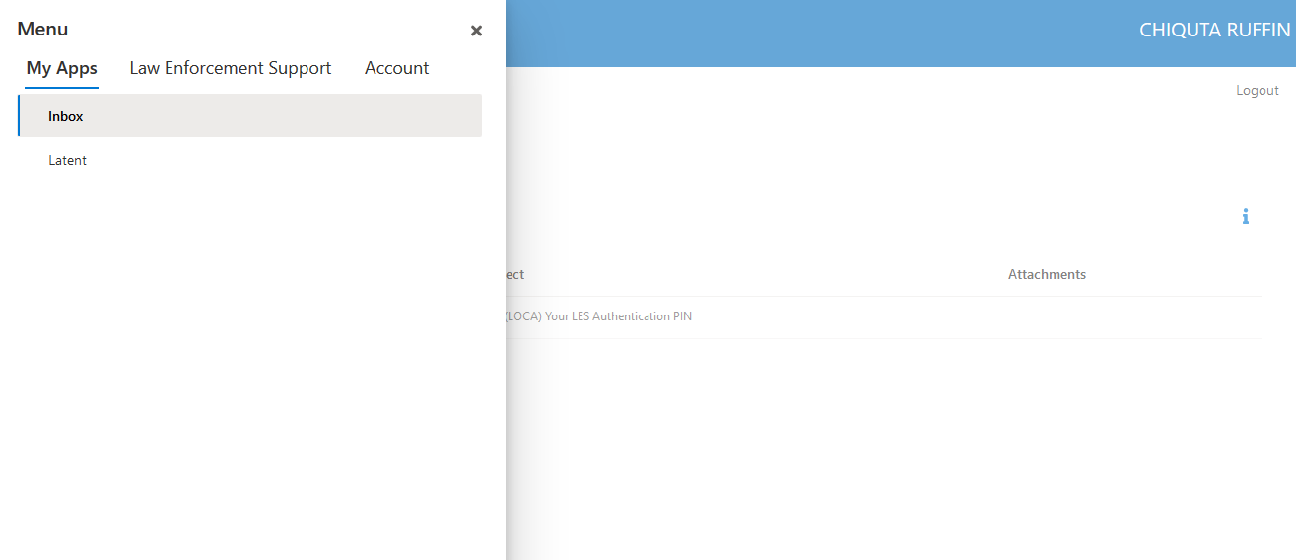
The form below will display and click on Creat Latent Entry.

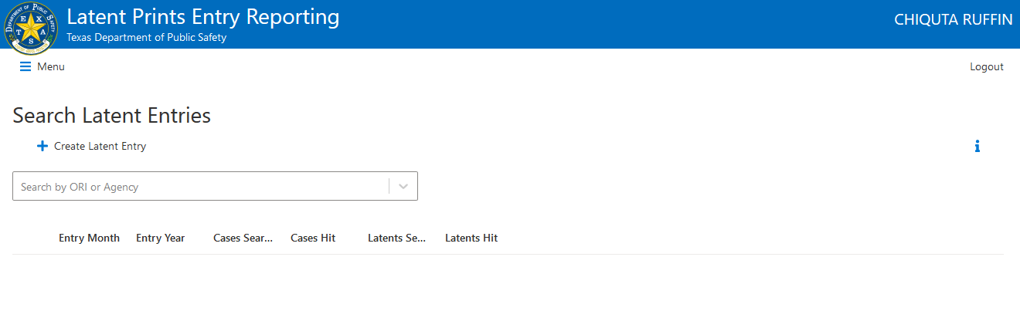

The form below will display:

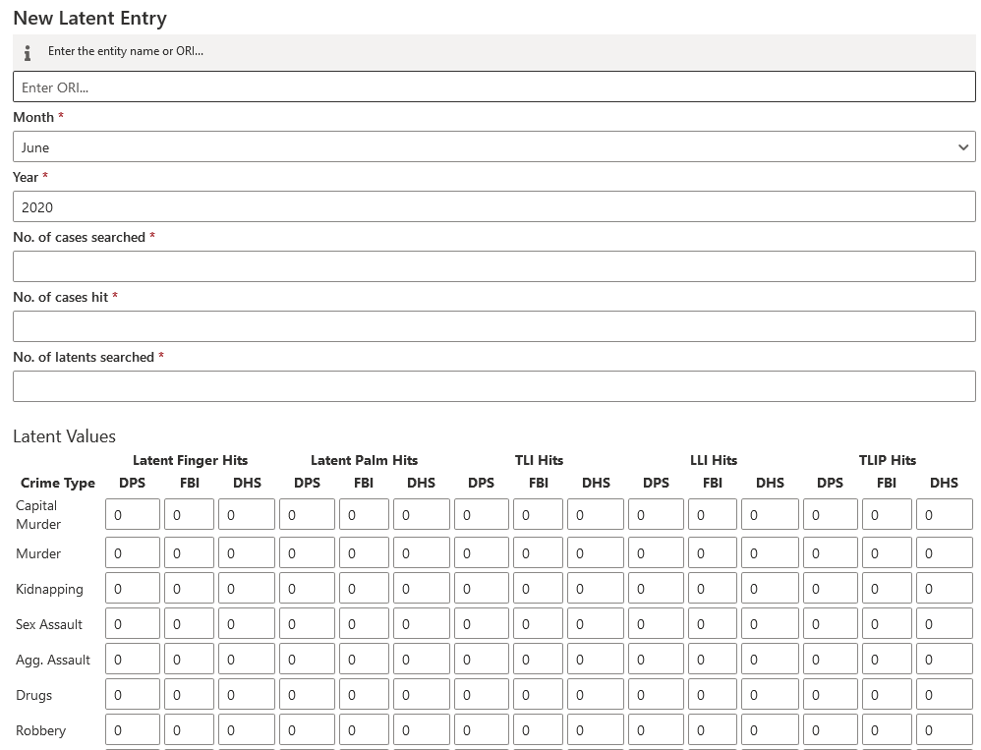

Enter the required fields, then enter any hits by crime type for DPS, FBI, or DHS for the selected month

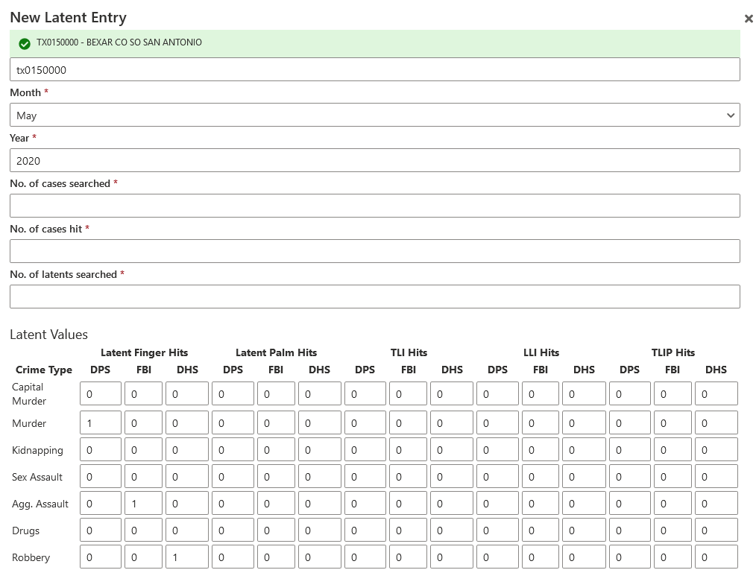

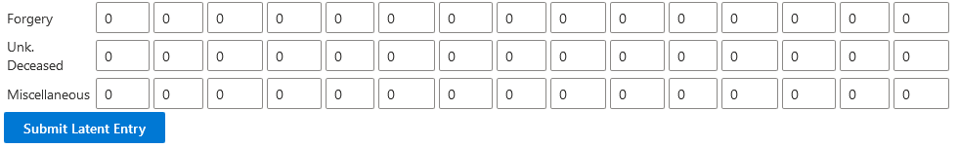

Select Submit Latent Entry. Any errors will be displayed with an error message: 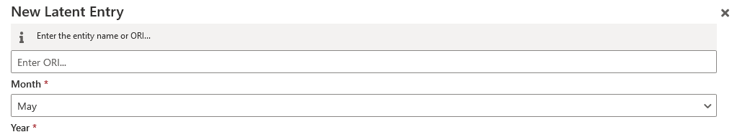

Once the report is accepted, it will display as shown below:

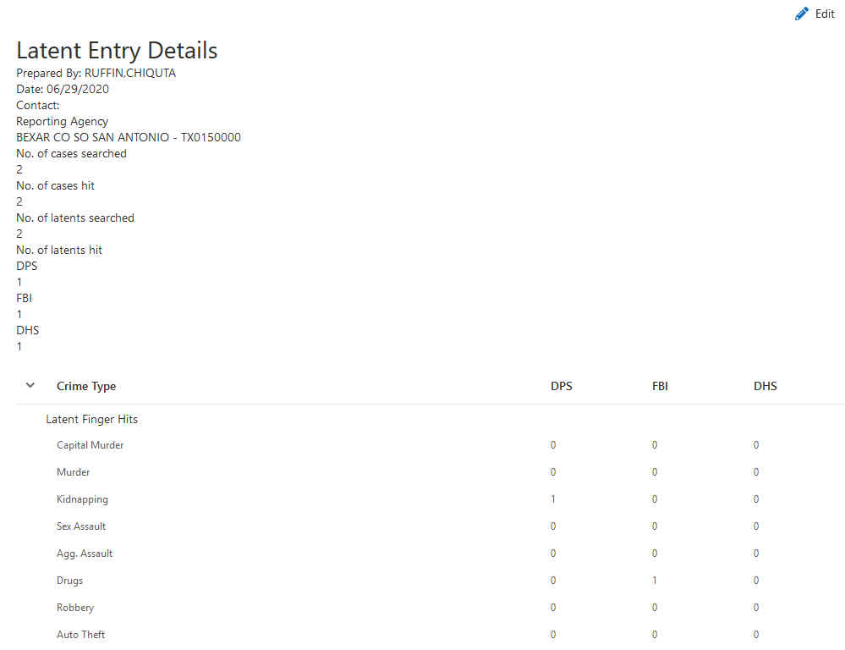

Edit

To edit a previously entered monthly report, click Edit Entry;
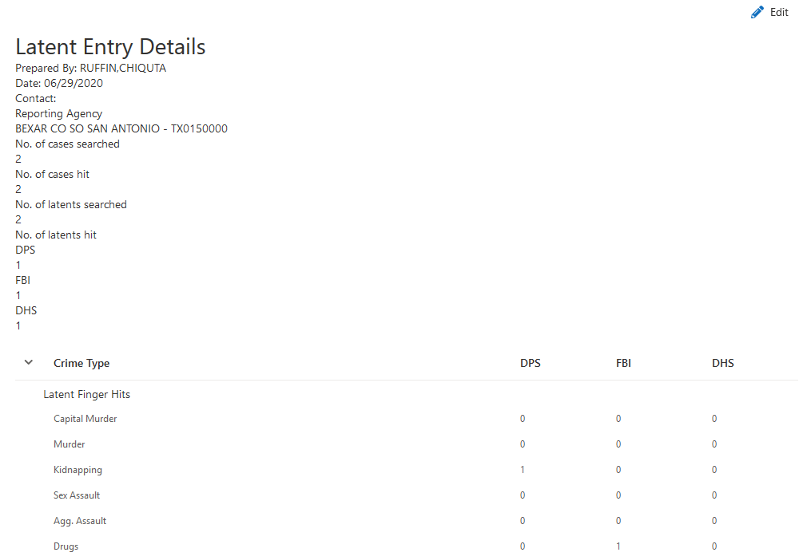

Make any necessary changes, click Submit Latent Entry, and

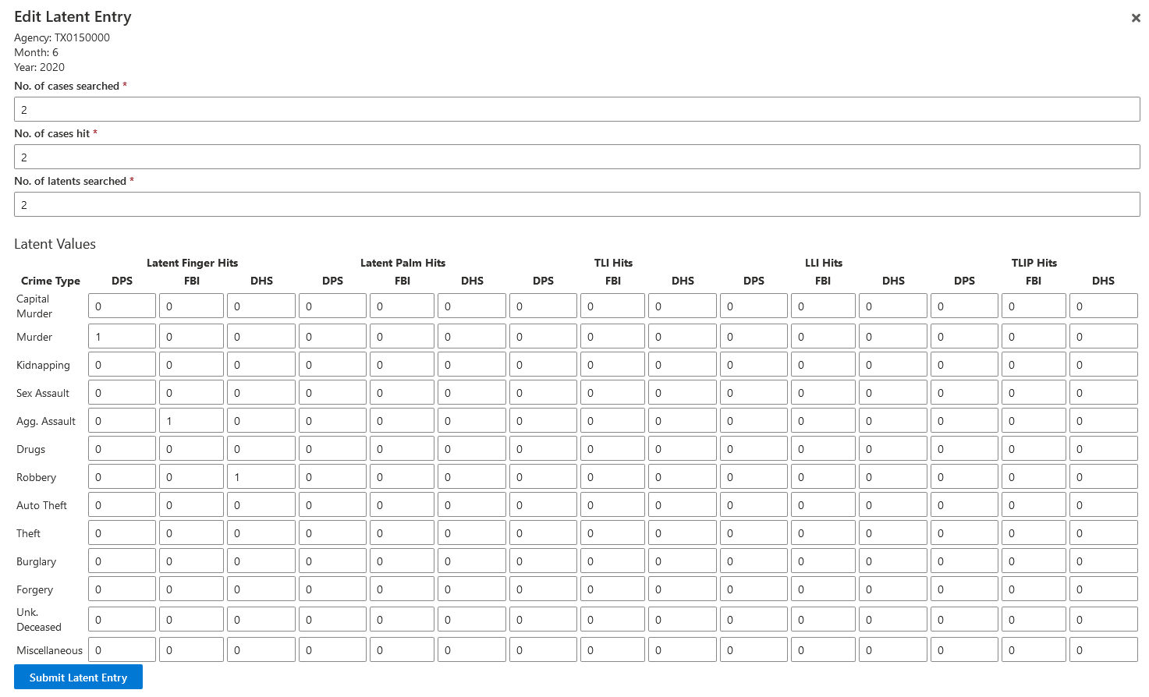
The updated report will display:

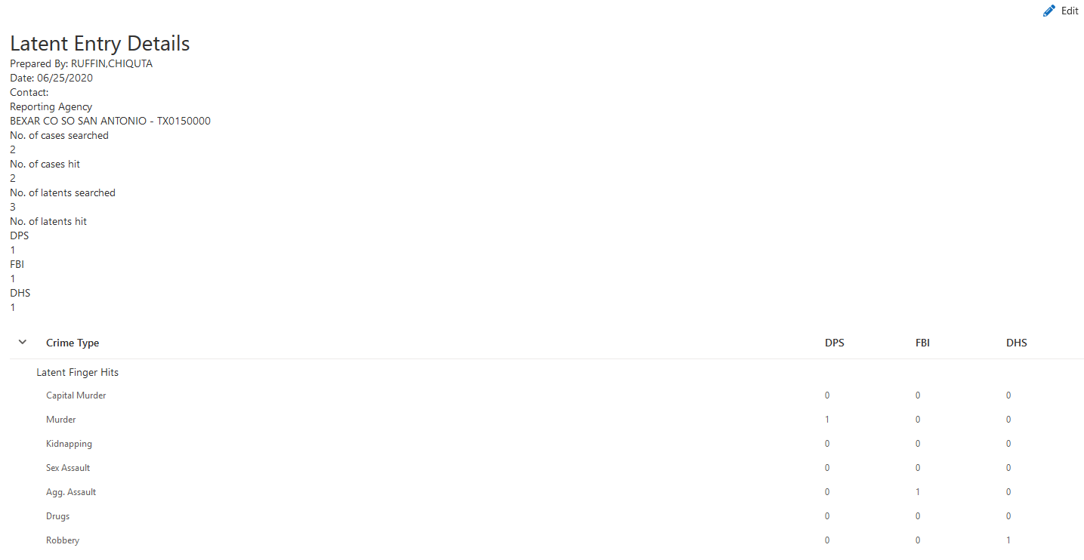

Search

To search previously entered monthly reports, go to My Apps and click on Latent Tab and it will display as shown below. Enter your agency ORI in the Search box;

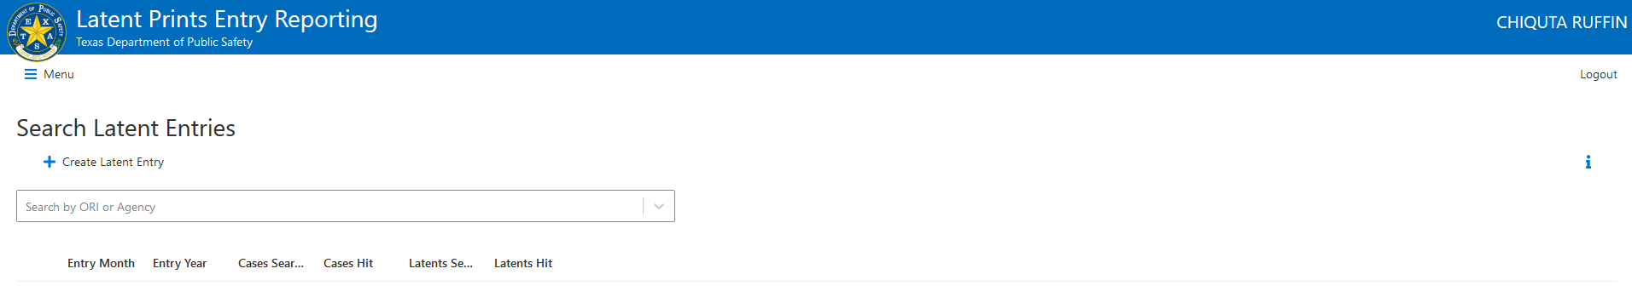

And a list of monthly reports for your county will display organized by filing year and month.

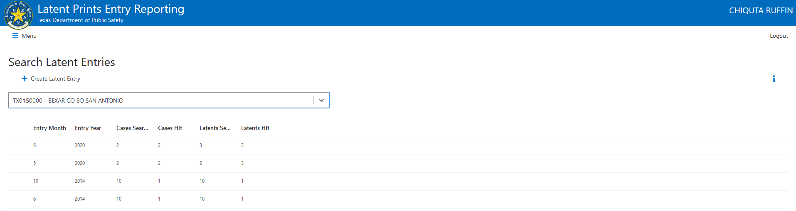

Click on any entry and the button will appear. Click to view or edit the report.
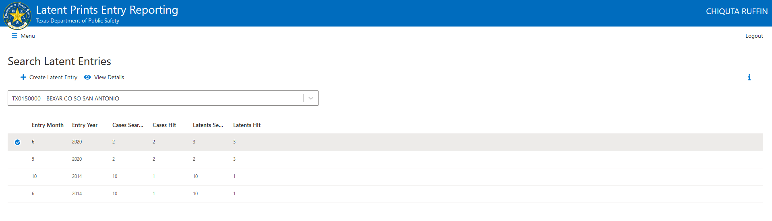

Document Revision History

Change 3. June 29, 2020
Version 1.1.2, Updated Latent Screen shots. Editor Chrystal Davila and Chiquta Ruffin

Change 2. April 12, 2016
Version 1.1.1, Updated Latent screen shots. Editor Jeffrey Tran

Change 1. August 12, 2013
Version 1.1.0, Added TLIP columns. Editor Angie Kendall

Change 0. February 6, 2012
Version 1.0.0, first document to be released. Editor Angie Kendall

