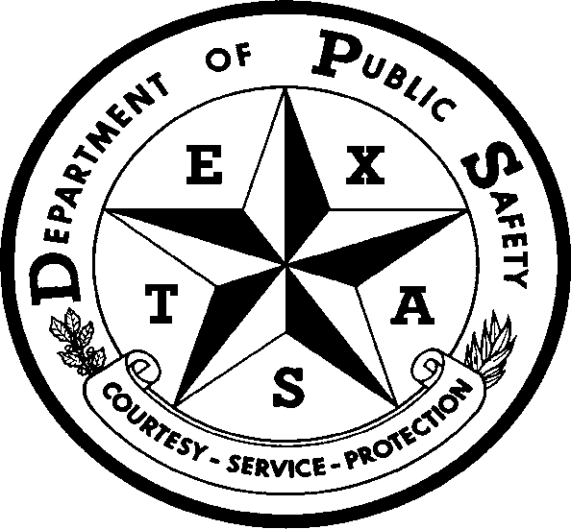 |  | REPORT OF VALID POSITIVE RESULT ON DRUG TEST UNDER TRC 644.252
A. ID | NAME OF MOTOR CARRIER |  |  |  |  | DATE OF DRUG TEST
 | NAME OF INDIVIDUAL TESTED |  | SOCIAL SECURITY NUMBER |  | CDL NUMBER & STATE |  |  | BIRTHDATE
B. INSTRUCTIONS | INSTRUCTIONS FOR THE COMPLETION OF THE  REPORT OF POSITIVE DRUG TEST UNDER TRC 644.252:  TO THE MOTOR CARRIER  - You must complete and sign the “Certificate of Motor Carrier” section.  - You must attach a legible copy of the signed the Federal Drug Testing, Custody and Control Form (with at least steps one through six completed) or the MRO’s signed report of positive controlled substance result. If the donor refused to provide a specimen, you do not need documentation from the MRO.  - Deliver or mail this form and the supporting documentation to: MCS Section Supervisor, Motor Carrier Bureau, Texas Department of Public Safety, 6200 Guadalupe, MSC# 0521, Austin, Texas 78752-4019. Legible copies may be sent by facsimile /email to 512-424-5310 or MCB.VPR@dps.texas.gov  - Retain a copy of this form and the Federal Drug Testing, Custody and Control Form and/or the MRO’s report of positive controlled substance result in the Motor Carrier records as required by 49 CFR, Parts 40 and 382 (or other parts applicable to CDL holders).  - You must forward your report to the department within ten days of receiving the completed test results.
C. CERTIFICATE OF MOTOR CARRIER | By signing below, I the authorized representative of the Motor Carrier listed above, certify the following:  1. The Motor Carrier listed above: Has an in-house drug and alcohol testing program that meets the federal requirements of 49 CFR Parts 40 and 382 (or other parts applicable to CDL holders); OR  Is a member of a consortium, as defined in 49 CFR 382.107, that provides drug and alcohol testing that meets the federal requirements of 49 CFR Parts 40 and 382 (or other parts applicable to CDL holders).
 | NAME OF CONSORTIUM:
 | 2. The individual tested is subject to drug testing by the Motor Carrier, and was tested for the following reason: Random Reasonable Suspicion Post-Accident Return to Duty Follow-up Pre-employment Other: ; AND
Tested positive for a prohibited drug under 49 CFR Parts 40 and 382 (or other parts applicable to CDL holders) (NOTE: a copy of the federal drug testing custody and control form or the MRO’s report of positive controlled substance result must be attached) ; OR

Refused to submit to a controlled substance test
(NOTE: Supporting documents are only required for pre-employment refusals)
I further certify that I have reviewed the motor carrier’s records and that the information contained in this certificate is true and correct to the best of my knowledge.
 | PRINTED NAME OF DESIGNATED MOTOR CARRIER REPRESENTATIVE TELEPHONE NUMBER
 | ADDRESS
 | SIGNATURE OF DESIGNATED MOTOR CARRIER REPRESENTATIVE  X |  |  | CITY |  | STATE | ZIP CODE
Mail form/attachments to the MCS Supervisor, Motor Carrier Bureau, Texas Department of Public Safety, 6200 Guadalupe,
MSC# 0521, Austin, Texas 78752-4019, FAX LEGIBLE copy to 512-424-5310 or email to MCB.VPR@dps.texas.gov .

MCS-20 (REV 03/20)

